THRIVE LDN COMMS TOOLKIT:
World Mental Health Day 2023 and related resources
Updated Wednesday, 27 September 2023
In this toolkit:
- Context and introduction
- For posting on World Mental Health Day
- Evergreen content:
- Free trauma-informed practice training
- #ZeroSuicideLDN campaign
- Cost-of-living signposting
- Thrive LDN conversation starter
For any further information on the contents of this toolkit please contact James Ludley and Becky Downer at: info@thriveldn.co.uk.
Context and introduction
World Mental Health Day takes place globally every year on 10th October. The theme for 2023 is ‘mental health is a universal human right’.
The day provides an opportunity to raise awareness around mental health, highlight the positive work that partners and stakeholders are doing across different sectors and create support for further change.
Below we have provided some suggested resources, information, and social media posts to mark the day should you wish to get involved. We have also included signposting for anyone that may need it, including many of which reflect public mental health resources developed for London.
Sharing training resources this World Mental Health Day
We know that many London partners will have established plans and content which you are planning to share to mark World Mental Health Day.
As such, we are seeking support from colleagues to help signpost to current training opportunities and campaigns from Thrive LDN, alongside your planned activity. This includes free online trauma-informed practice training and the ongoing #ZeroSuicideLDN campaign.
- The Gift of Reconnection: trauma-informed practice training
Thrive LDN has been working with Nicola Lester Psychological Trauma Consultancy to develop free, online trauma-informed practice training to support individuals and organisations.
To complete all the trauma-informed practice training takes close to 5 hours in total. Thousands of people have already accessed the training and building on feedback, we have developed a bitesize approach to help make things more manageable and less overwhelming.
New for World Mental Health Day, you can now subscribe to an eight-week programme and you’ll receive the training chapter-by-chapter direct into your inbox. This means spending around 30 minutes per week engaging with the training.
By week 8 participants will have fully completed the training programme and will be awarded gold level status ‘Committed to Trauma Informed Practice’.
- #ZeroSuicideLDN campaign
We are continuing to encourage partners to support the #ZeroSuicideLDN campaign and help promote the Zero Suicide Alliance’s free suicide prevention training.
You can share your support for the campaign by using the social copy provided in this toolkit which we have updated for autumn and winter months.
Additionally, follow Hounslow’s example by sharing your own videos and pictures with our training posters. All local borough posters are available to download as well as translated versions too.
If you’d like to request your own A2 hard copy poster(s), please contact info@thriveldn.co.uk.

For posting on World Mental Health Day – Tuesday, 10 0ctober 2023
Below we have put together suggested posts for social media channels to sit alongside other planned content on World Mental Health Day. See below sections for ‘evergreen’ and other content, including website and newsletter copy.
Channel | Suggested copy | Example assets and links for more
Twitter (1) | Today is #WorldMentalHealthDay. It’s never been more important to think and talk more about mental health.  Do you have 20 minutes to take free #ZeroSuicideLDN training? Together we can break the stigma surrounding suicide and mental health.  Access now: www.thriveldn.co.uk/zerosuicideldn | 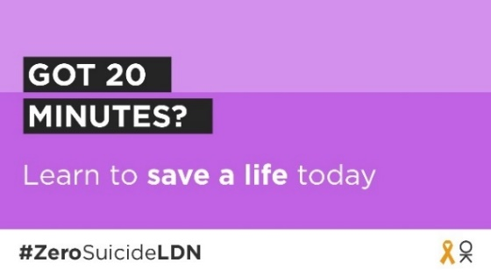  Alt text: Text on graphic reads: Got 20 minutes? Learn to save a life today. #ZeroSuicideLDN
Twitter (2) | Today for #WorldMentalHealthDay, @ThriveLDN is helping Londoners support those around them by offering free online trauma-informed training.  The training is designed for anyone in a role supporting others, whether formal or informal.  Find out more: www.thriveldn.co.uk/trauma-informed | 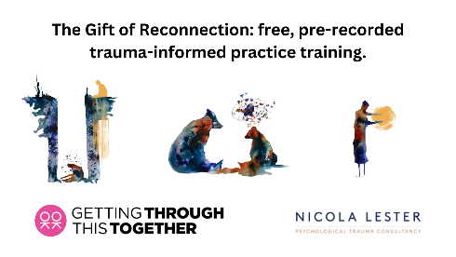  Alt text: A promotional graphic. The text at the top reads The Gift of Reconnection: free, pre-recorded online trauma-informed practice training. Below are three abstract images to signify the three levels of the training. Firstly, a person in a well, secondly two bears facing each other, thirdly a person holding a golden orb. Below sits the training providers’ logos.  Alt text: A laptop is open at a desk and on screen is the beginning of the trauma-informed video.
Twitter (3) | Talking about mental health is important, but it isn’t always easy.  This #WorldMentalHealthDay explore @ThriveLDN's conversation starter tool to find tips and prompts to help you get your community talking. Updated for cost-of-living prompts.  Explore: https://thriveldn.co.uk/communications/toolkits-and-resources/toolkit/thrive-ldn-mental-health-conversation-starter/ | 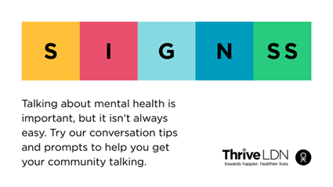  Alt Text: A graphic that highlights the conversation starter tool SIGNSS framework. The text below says “Talking about mental health is important, but it isn’t always easy. Try our conversation tips and prompts to get your community talking.”
Instagram | This #WorldMentalHealthDay access @ThriveLDN's free trauma informed training to support individuals and organisations. The training is offered across three levels: Bronze, Silver & Gold.  The training is delivered by Nicola Lester Psychological Trauma Consultancy. At each level, participants receive a certificate of completion and certified badge.  You can do it in your own time (it takes around 5 hours in total) or subscribe to their 8-week programme to make it more manageable.  Follow the link in @ThriveLDN bio or visit their website to take the training.  #TraumaInformed  #TraumaAware | Alt text: A laptop is open at a desk and on screen is the beginning of the trauma-informed video.
Facebook and LinkedIn | Living and working in London can be stressful, and right now for some it may be overwhelming. Would you be able to spot a colleague or friend in distress?  That is why for World Mental Health Day, we are encouraging Londoners to take the Zero Suicide Alliance’s free, online training to know what to do if a loved one, colleague or stranger is in crisis.  Learn to save a life today... take the training.  Visit: www.thriveldn.co.uk/zerosuicideldn | 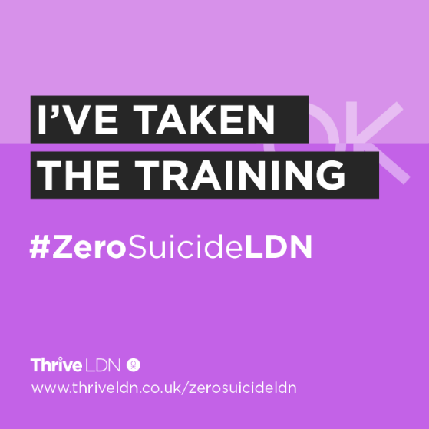  Text on graphic reads: I’ve taken the training. #ZeroSuicideLDN.  More assets: https://drive.google.com/drive/u/0/folders/189EzBGDyPA96jr-Tw6-sTIh2egGI_CdE

- Free trauma-informed practice training
We know that some Londoners will have experienced events or circumstances that may have exposed them to trauma including abuse, neglect, interpersonal violence, community violence, racism, discrimination, or war. As a result, it is increasingly important that we are able to adopt a trauma-informed approach through our collective work to support individuals or communities.
Thrive LDN has been working with Nicola Lester Psychological Trauma Consultancy to offer free, online trauma-informed practice training to support individuals and organisations.
The training is offered across three levels, Bronze, Silver and Gold. To complete all the trauma-informed practice training takes close to 5 hours in total. At each level, participants receive a certificate of completion and certified badge which can be used to demonstrate their knowledge and trauma informed training status. Training is free to complete and does not require registration to join.
There are three ways in which participants can choose to take the training:
- Complete each level in your own time. You can access a continuous playlist of the training videos on Thrive LDN’s YouTube channel.
- Participate in the training as a group. Whilst the training can be accessed individually, some groups or organisations may prefer to participate together, either in person or online. Each training level has a brief facilitation guide will support group engagement and enhance opportunities for discussion and shared learning.
- Subscribe to an eight-week programme and you’ll receive the training chapter-by-chapter direct into your inbox. This means spending around 30 minutes per week engaging with the training.
More details and additional resources associated with the training can be found on the Thrive LDN website.
Promoting the training
Below we have provided some suggested copy for digital channels which you may find useful to promote the training opportunity to your networks, internally and externally.
Channel | Suggested post | Assets (right click to open and download each asset)
Twitter (1) | Access @ThriveLDN's free trauma informed training to support individuals and organisations. The training is offered across three levels: Bronze, Silver & Gold.  All training and supporting resources can be accessed online via: www.thriveldn.co.uk/trauma-informed  #TraumaInformed  #TraumaAware | All digital assets.  Static image:  Alt text: A promotional graphic. The text at the top reads The Gift of Reconnection: free, pre-recorded online trauma-informed practice training. Below are three abstract images to signify the three levels of the training. Firstly, a person in a well, secondly two bears facing each other, thirdly a person holding a golden orb. Below sits the training providers’ logos.  Alt text: A laptop is open at a desk and on screen is the beginning of the trauma-informed video.  Video:
Twitter (2) | Trauma is a normal reaction to an abnormal situation. It affects everything a person experiences.  @ThriveLDN is offering free online trauma-informed practice training. Sign up to begin your 8-week course and become committed to trauma informed practice.  https://thriveldn.co.uk/communications/toolkits-and-resources/toolkit/trauma-informed-practice-training/#bitesize_option
Twitter (3) | FREE TRAINING: @ThriveLDN is offering free, online trauma-informed practice training. For around 30 minutes a week you could become certified committed to trauma informed practice in just 8 weeks.  Sign up and begin your training journey today: https://thriveldn.co.uk/latest/news-and-blog/all/become-gold-level-trauma-informed-in-just-eight-weeks/
Instagram | Trauma is a normal reaction to an abnormal situation, and it affects everything – how we think, learn, remember, feel about ourselves and others, and the way we make sense of the world.  Becoming trauma aware enables us to support those who may be struggling or experiencing challenges.  @ThriveLDN has partnered with Nicola Lester Psychological Trauma Consultancy to offer free, pre-recorded trauma-informed practice training across three levels: Bronze, Silver and Gold.  At each level, participants receive a certificate of completion and certified badge.  Follow the link in @ThriveLDN bio or visit their website to take the training.  You can do it in your own time (it takes around 5 hours in total) or subscribe to their 8-week programme to make it more manageable.  #TraumaInformed  #TraumaAware | All digital assets.  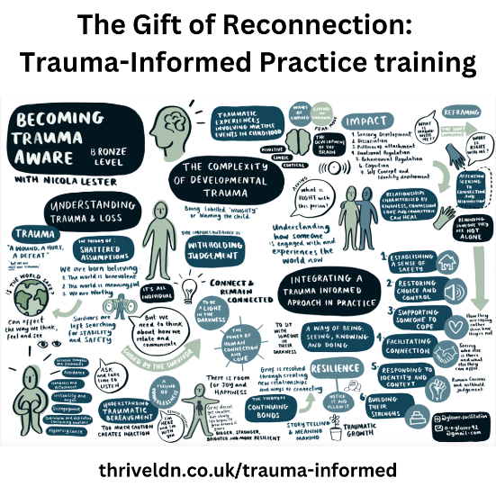  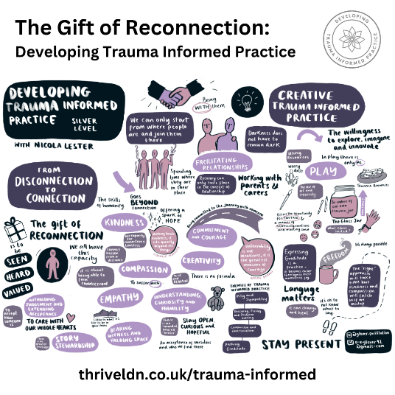  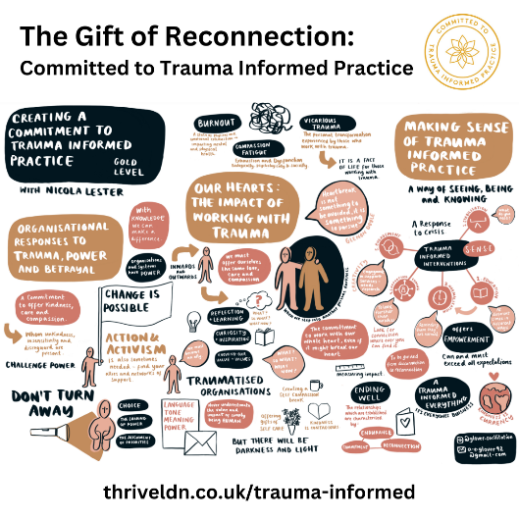  Alt text: A series of memory aids which has been developed to support the training. It goes through the various chapters.
Facebook | How trauma aware are you?  Thrive LDN has partnered with Nicola Lester Psychological Trauma Consultancy to develop free, online trauma-informed practice training to support individuals and organisations.  Becoming trauma aware enables us to support those who may be struggling or experiencing challenges.  The training is offered across three levels: Bronze, Silver and Gold.  At each level, participants receive a certificate of completion and certified badge.  You can do it in your own time (it takes around 5 hours in total) or subscribe to Thrive LDN’s 8-week programme to make it more manageable.  For all the training and resources, visit: www.thriveldn.co.uk/trauma-informed | 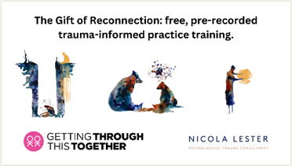  Alt text: A promotional graphic. The text at the top reads The Gift of Reconnection: free, pre-recorded online trauma-informed practice training. Below are three abstract images to signify the three levels of the training. Firstly, a person in a well, secondly two bears facing each other, thirdly a person holding a golden orb. Below sits the training providers’ logos.  Alt text: A laptop is open at a desk and on screen is the beginning of the trauma-informed video.  Download all digital assets.
LinkedIn | Become gold level trauma-informed in just eight weeks…  Thrive LDN has partnered with Nicola Lester Psychological Trauma Consultancy to develop free, online trauma-informed practice training to support individuals and organisations.  To complete all the available training, starting from the introduction, takes close to 5 hours in total.  Building on feedback, Thrive LDN has developed a bitesize approach to help make things more manageable and less overwhelming.  Subscribe to an eight-week programme and you’ll receive the training chapter-by-chapter direct into your inbox. This means you can spend around 30 minutes per week engaging with the training.  By week 8 you’ll have fully completed the training programme and will be awarded gold level status ‘Committed to Trauma Informed Practice’.  Sign up today: https://thriveldn.co.uk/latest/news-and-blog/all/become-gold-level-trauma-informed-in-just-eight-weeks/ | Alt text: A laptop is open at a desk and on screen is the beginning of the trauma-informed video.
Newsletter | Become gold level trauma-informed in just eight weeks…  Thrive LDN has partnered with Nicola Lester Psychological Trauma Consultancy to develop free, online trauma-informed practice training to support individuals and organisations.  Subscribe to an eight-week programme to receive the training chapter-by-chapter direct into your inbox. This means you can spend around 30 minutes per week engaging with the training.  By week 8 you’ll have fully completed the training programme and will be awarded gold level status ‘Committed to Trauma Informed Practice’.  Sign up today: https://thriveldn.co.uk/latest/news-and-blog/all/become-gold-level-trauma-informed-in-just-eight-weeks/ | Alt text: A laptop is open at a desk and on screen is the beginning of the trauma-informed video.
Website article | Become gold level trauma-informed in just eight weeks  Thrive LDN has been working with Nicola Lester Psychological Trauma Consultancy to develop free, online trauma-informed practice training to support individuals and organisations.  1,000s of people have already accessed the training. The feedback has been really positive.  The training is designed for anyone in a role supporting others, whether formal or informal. However, participating in the training supports an understanding of how trauma influences and shapes the lives of those it touches regardless of previous knowledge or role.  To complete all the training and reach gold level takes close to 5 hours in total. Building on feedback, Thrive LDN has developed a bitesize approach to help make things more manageable and less overwhelming.  Subscribe to an 8-week programme and you’ll receive the training chapter-by-chapter. This means you can spend around 30 minutes per week engaging with the training.  By week 8 you’ll have fully completed the training programme and will be awarded gold level status ‘Committed to Trauma Informed Practice’.  Sign up today.  About the trainer and offer  Nicola Lester is a registered mental health nurse by background, specialising in working with psychological trauma and developing trauma informed approaches to practice across a range of contexts, both in the UK and overseas.  This series of trauma informed training sessions are funded and supported by the Mayor of London to support Londoners recover from the mental health impacts of the pandemic and face the cost-of-living crisis.

- #ZeroSuicideLDN campaign
Four years ago, the citywide #ZeroSuicideLDN campaign was launched by the Mayor of London and partners to encourage Londoners to access the Zero Suicide Alliance’s free, online suicide prevention training.
The Zero Suicide Alliance is a collaborative of National Health Service trusts, businesses and individuals who are all committed to suicide prevention in the UK and beyond. The alliance is ultimately concerned with improving support for people contemplating suicide by raising awareness of and promoting free suicide prevention training which is accessible to all.
To date, more than 360,000 people across the capital have completed the training supported by the #ZeroSuicideLDN campaign.
We’re asking partners to continue to support and share the campaign, especially at a time where increased cost-of living pressures have been significant for many across the city and have had a detrimental impact on Londoners’ mental health and wellbeing.
There has never been a more important time to shine a light on the campaign and encourage Londoners to learn how to support those around them who may be in crisis.
Channel | Suggested post | Assets
Twitter (1) | We all need to look out for one another. That's why we are supporting #ZeroSuicideLDN to encourage everyone to take free, online training to know what to do if a loved one, colleague, or stranger is in crisis.  Learn to save a life today...  Visit 👉 www.thriveldn.co.uk/ZeroSuicideLDN | Full range of #ZeroSuicideLDN assets:  Google Drive:  https://drive.google.com/drive/folders/189EzBGDyPA96jr-Tw6-sTIh2egGI_CdE?usp=drive_link  ZIP file:  Download as a ZIP file (64MB).  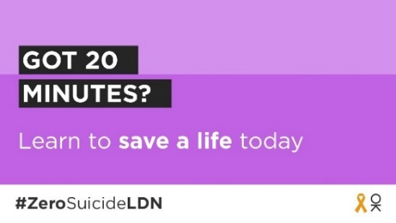  Alt text: Text on graphic reads: Got 20 minutes? Learn to save a life today. #ZeroSuicideLDN.  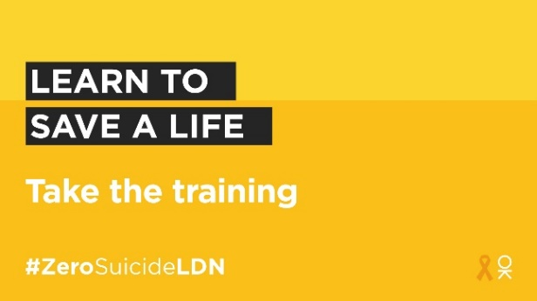  Alt text: Text on graphic reads: Learn to save a life. Take the training. #ZeroSuicideLDN.
Twitter (2) | It’s never been more important to think and talk more about mental health.  That’s why we're taking #ZeroSuicideLDN @Zer0Suicide free suicide prevention training to learn what to do if a loved one, colleague or stranger is at risk of suicide.  You can too.  https://zerosuicidealliance.com/training
Twitter (3) | Some people may be finding life harder than usual at the moment. It's vital we all look out for each other, in case someone may be in crisis.  That's why we are supporting the #ZeroSuicideLDN campaign. You can too, it only takes 20 minutes.  Visit 👉 www.thriveldn.co.uk/zerosuicideldn
Twitter (4) | London works best when we all work together and look after each other. 🧡  There's FREE online 20-minute training available to help us all to spot the signs when someone may be thinking about taking their life.  Visit https://zerosuicidealliance.com/training  #ZeroSuicideLDN
Twitter (5) | For some Londoners right now, worries over money or debt may be overwhelming. Would you be able to spot a neighbour or friend in distress?  There’s free @Zer0Suicide online training to help.  Visit https://zerosuicidealliance.com/training  #ZeroSuicideLDN
Twitter (7)  NHS urgent mental health support lines signposting | Life can be really difficult, and you might sometimes feel completely overwhelmed. But remember, a mental health emergency should be taken as seriously as a physical one.  Find your local NHS urgent mental health helpline for 24/7 advice and support.  👉 www.nhs.uk/service-search/mental-health/find-an-urgent-mental-health-helpline | 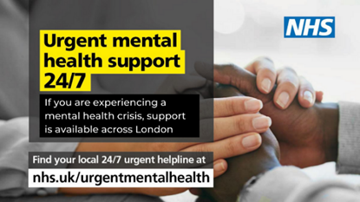  More assets: https://drive.google.com/drive/folders/1P35u0hUFqd2LTKYM6ThatE1SMA2EoHIB
Instagram | Have you got 20 minutes to learn how to save a life today?  Around 10 people a week take their own life in London. We want to encourage Londoners to take the FREE online training provided by the @zerosuicidealliance so they know what to do if a loved one, colleague or stranger is in crisis.  Learn to save a life today...take the training.  Visit 👉 thriveldn.co.uk/zerosuicideldn  Or find details in @ThriveLDN bio.  #ZeroSuicideLDN  #ThroughTogether | 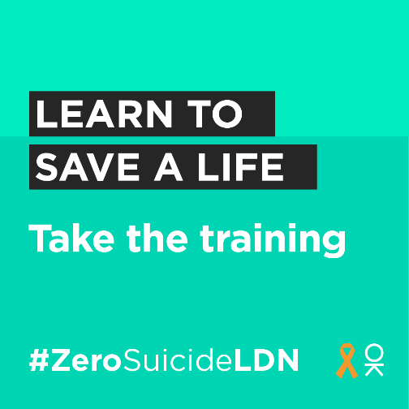  Alt text: Text on graphic reads: Learn to save a life. Take the training. #ZeroSuicideLDN.  More assets: https://drive.google.com/drive/u/0/folders/189EzBGDyPA96jr-Tw6-sTIh2egGI_CdE
Facebook and LinkedIn | Living and working in London can be stressful, and right now for some it may be overwhelming. Would you be able to spot a colleague or friend in distress?  That is why we want to encourage Londoners to take the Zero Suicide Alliance’s free, online training to know what to do if a loved one, colleague or stranger is in crisis.  Learn to save a life today...take the training. Visit: www.thriveldn.co.uk/zerosuicideldn | 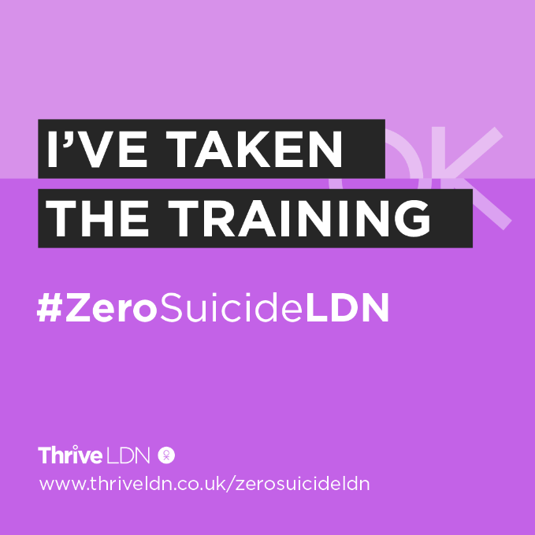  Text on graphic reads: I’ve taken the training. #ZeroSuicideLDN.  More assets: https://drive.google.com/drive/u/0/folders/189EzBGDyPA96jr-Tw6-sTIh2egGI_CdE
LinkedIn (for individuals) | I’ve taken The Zero Suicide Alliance’s suicide prevention training.  It’s never been more important to think and talk more about mental health. The free training is a really helpful way to learn what to do if a loved one, colleague, or stranger is in a crisis or at risk of suicide.  Learn to save a life today, join me in supporting the #ZeroSuicideLDN campaign.  Visit Thrive LDN’s website for more details: www.thriveldn.co.uk/zerosuicideldn | 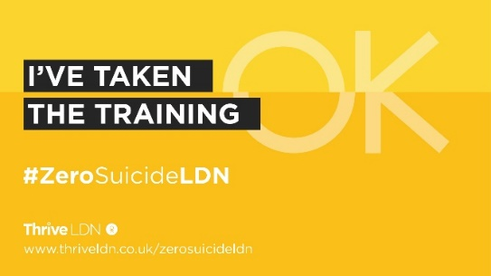  Text on graphic reads: I’ve taken the training. #ZeroSuicideLDN.  More assets:  https://drive.google.com/drive/u/4/folders/1ywBx_uVXKPh4AXorsQJqBCzyy4lKpxSc

- Support with money worries (cost-of-living signposting)
We are encouraging partners to signpost to information on how to manage financial anxiety and uncertainty, alongside resources which support mental health and wellbeing.
The below suggested social media posts support signposting to relevant services that will support Londoners with money worries. Please consider incorporating these alongside any other planned communications on this topic/ area or when aligning with suicide prevention communications.
In summary:
- Financial resilience and feelings of control relating to finance have a profound impact on people’s wellbeing.
- Employment and financial security have a two-way relationship with overall mental health, with stable, consistent employment and the ability to save money act as protectors of mental health whereas debt, unemployment, and financial instability act as some of the main barriers to emotional wellbeing.
- The challenges posed by the cost-of-living crisis are being felt unevenly across London, exposing differences of vulnerability across geographies and social groups. As such, more Londoners will be considered vulnerable to suicide.
- In response to this it is vital for London to take a public mental health approach to its response to ensure that the wellbeing of Londoners is prioritised alongside the growth of London’s economy.
Support with money worries (below links could be localised)
Channel | Suggested post | Assets (access all money worries assets)
Twitter – Debt Free Advice | For some Londoners right now, worrying about money may feel overwhelming or leaving you feeling very anxious.  If you are worried about money or need free, impartial advice, @DebtFreeAdvice_’s advice line is there to help.  Call 0800 808 5700 or visit www.debtfreeadvice.com | 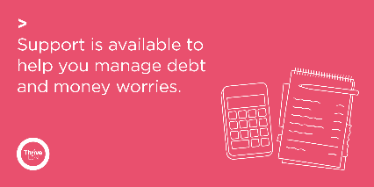  Alt text: Graphic reads: Support is available to help you manage debt and moey worries. Alongside a line drawing of a calculator and note pad.  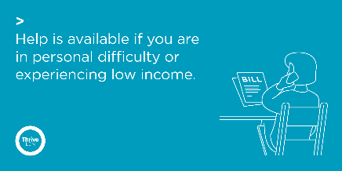  Alt text: Graphic reads: Help is available if you are in personal difficulty or experiencing low income. Alongside a line drawing of a person on the phone with a document in front of them with the word ‘Bill’ written on it.
Twitter – supporting debt and money worries 1 | For some Londoners right now, worries over money or debt may be overwhelming.  If you are worried about money or need impartial advice, there is support available. Ask for help if you need it.  @DebtFreeAdvice_ 0800 808 5700  @CAPuk 0800 328 0006  Or visit www.nhs.uk/mental-health/advice-for-life-situations-and-events/how-to-cope-with-financial-worries/
Twitter – supporting debt and money worries 2 | Talking about financial concerns and difficulties is challenging. But you are not alone, and there is nothing to be ashamed of.  Talk to someone you trust💬  Reach out to friends and family🤝  If you need advice there is support available: www.london.gov.uk/what-we-do/communities/help-cost-living/help-if-money-worries-are-affecting-your-mental-health  #ThroughTogether
Twitter – supporting debt and money  worries 3 | Accessing help and support for financial difficulties is really important. And doing what you can to stay well will help you deal with things better.  Talk to someone you trust 💬  Take things one step at a time ☝️  Focus on what you can control 👤  Reach out to friends & family 🤝
Twitter – personal difficulty | If you find yourself in urgent financial or personal need, there is support and information available for you. Please seek help if you need it.  💷 @turn2us_org: 0808 802 2000  🏘️ @Shelter: 0344 515 1540  🥫 @TrussellTrust: 0808 208 2138  Or visit www.london.gov.uk/what-we-do/communities/help-cost-living/
Twitter – Good Thinking resources | If you’re feeling the strain financially and things seem overwhelming, you can take small steps to help you stay mentally healthy.  @GoodThinkingUK has lots of practical tips and links to organisations that can help ease the pressure: www.good-thinking.uk/articles/cost-living-crisis-how-look-after-your-mental-health  #ThroughTogether | 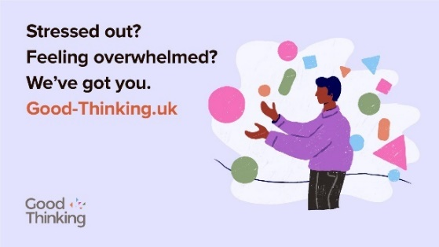  Find relevant Good Thinking assets:  https://drive.google.com/drive/folders/1A-QcbmAUo1Rbxi6IUAS8kYGzBxUlZm3Z
Instagram | For some Londoners right now, worrying about money may feel overwhelming or leaving you feeling very anxious.  If you are worried about money or need free, impartial advice, @debtfreeadvice’s advice line is there to help.  Call 0800 808 5700 or visit debtfreeadvice.com  If you find yourself in urgent financial or personal need, there is support and information available for you. Please seek help if you need it.  💷 @turn2us_org: 0808 802 2000  🏘️ @sheltercharity: 0344 515 1540  🥫 @trusselltrust: 0808 208 2138  Find more advice by searching ‘GLA Cost of Living Hub’. | 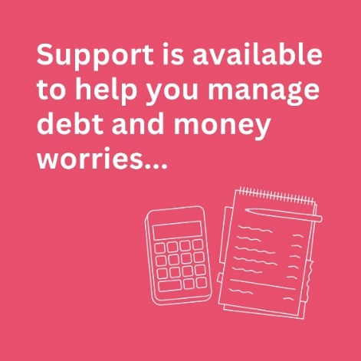  Alt text: Graphic reads: Support is available to help you manage debt and moey worries. Alongside a line drawing of a calculator and note pad.  Alt text: Graphic reads: Support is available to help you manage debt and moey worries. Alongside a line drawing of a calculator and note pad.
Instagram | Talking about financial concerns and difficulties is challenging. But you are not alone and there is nothing to be ashamed of.  If you need support and impartial advice, there are free professional services available.  Accessing help and support for financial difficulties is really important. But so is also doing what you can to stay well, which will help you deal with things better.  Talk to someone you trust 💬  Take things one step at a time ☝️  Focus on what you can control 👤  Reach out to friends and family 🤝  For a range of information to support Londoners, including on money and mental health, search ‘GLA help with the cost of living online hub’.  And for more ideas on looking after your own wellbeing, @ThriveLDN has simple tools, ideas and inspiration. Follow the link in their bio.  #ThroughTogether
Facebook / LinkedIn | For some Londoners right now, worrying about money may feel overwhelming or leaving you feeling very anxious.  If you are worried about money or need free, impartial advice is available. Debt Free Advice is there to help.  Call free on 0800 808 5700 or visit: www.debtfreeadvice.com  The Mayor of London has published a Help With the Cost of Living online hub which contains a range of information to support Londoners, including on money and mental health: https://www.london.gov.uk/what-we-do/communities/help-cost-living | Alt text: Graphic reads: Support is available to help you manage debt and moey worries. Alongside a line drawing of a calculator and note pad.
Facebook / LinkedIn | Talking about financial concerns and difficulties is challenging. But you are not alone and there is nothing to be ashamed of.  If you need support and impartial advice, there are free professional services available.  Accessing help and support for financial difficulties is really important. But so is also doing what you can to stay well, which will help you deal with things better.  Talk to someone you trust 💬  Take things one step at a time ☝️  Focus on what you can control 👤  Reach out to friends and family 🤝  The Mayor of London’s Help With the Cost of Living online hub contains a range of information to support Londoners, including on money and mental health: https://www.london.gov.uk/what-we-do/communities/help-cost-living

- Thrive LDN conversation starter
Thrive LDN’s conversation starter tool helps Londoners engage with friends, family, neighbours or those they support in the community or workplace about good mental health, wellbeing and financial worries. As well as importantly knowing the most appropriate help and advice services to signpost to for professional support.
Download the conversation starter resource (PDF):
- Cost-of-living version (November 2022)
- Covid version (January 2021)

The conversation starter tool is also embedded in the Good Thinking guides to looking out for those around you. Four tailored guides with three simple steps to help you spot the signs of poor mental health in others, check in and let them know you care and help them get the support they need.
Download the guides (PDF):
- Looking out for those around you
- Looking out for friends and colleagues at work
- Looking out for your friends – a guide to help children and young people support friends
- Looking out for children and young people – a guide for parents and carers

Channel | Suggested post | Assets
Twitter 1 | Talking about mental health is important, but it isn’t always easy.  Explore @ThriveLDN's conversation starter tool to find tips and prompts to help you get your community talking.  https://thriveldn.co.uk/communications/toolkits-and-resources/toolkit/thrive-ldn-mental-health-conversation-starter/ | Alt Text: A graphic that highlights the conversation starter tool SIGNSS framework. The text below says “Talking about mental health is important, but it isn’t always easy. Try our conversation tips and prompts to get your community talking.”  Alt Text: Two people are walking a dog in an open green space and havening a chat. The text above them reads: When did you last talk to someone you care about?  More assets: https://drive.google.com/drive/folders/16eX6qdbW0L9d5I-rnS2Lk7DVKvJhoFhl?usp=share_link
Twitter 2 | It’s not always easy for someone to talk about how they’re feeling or share their concerns.  Why not reach out to a friend or loved one to get them talking.  Explore some ways in which you can start such conversations: www.thriveldn.co.uk/communications/toolkits-and-resources/toolkit/thrive-ldn-mental-health-conversation-starter/
Twitter 3 | Reaching out to someone could help them know that someone cares and help them find the support they need.  Explore @ThriveLDN’s tips on having a supportive conversation: thriveldn.co.uk/communications/toolkits-and-resources/toolkit/thrive-ldn-mental-health-conversation-starter/
Twitter 4 | In these tough times, it's important to look out for those around you.  Remember to check in with friends, family and workmates.  @GoodThinkingUK's guides lead you through 3 easy steps to help if someone you know is struggling: https://www.good-thinking.uk/how-guides/quick-guides-support-others | Alt Text: A graphic that highlights the Good Thinking guides to looking out for those around you. The text below says “Good Thinking’s guide to looking out for those around you” and includes a link to access the guides, “good-thinking.uk/how-guides”. Illustration of a group of people of various ages and genders sat under a tree.  Download: https://drive.google.com/drive/u/1/folders/1eegJjVGiRoAULb-uKP4zhwiqdjmsMsTA
Twitter 5 | Starting a conversation about mental health with your child can be tough.  @GoodThinkingUK's guide leads you through 3 easy steps to help you check in and get them the support they need: https://www.good-thinking.uk/how-guides/quick-guides-support-others  Let them know you are there for them ❤️ | 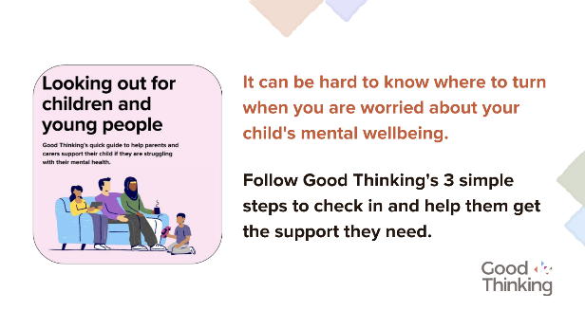  Alt Text: A graphic that highlights the Good Thinking guide for parents and carers to looking out for children and young people. Illustration of a family sat together on a sofa.  Download: https://drive.google.com/drive/u/1/folders/1eegJjVGiRoAULb-uKP4zhwiqdjmsMsTA
Instagram 1 | When times are tough, it’s important that we look after our own and each other's wellbeing.  Reaching out to someone could help them know that someone cares, that they are valued, and help them find the support they need.  Explore @ThriveLDN’s tips on having a supportive conversation - click the link in their bio. | 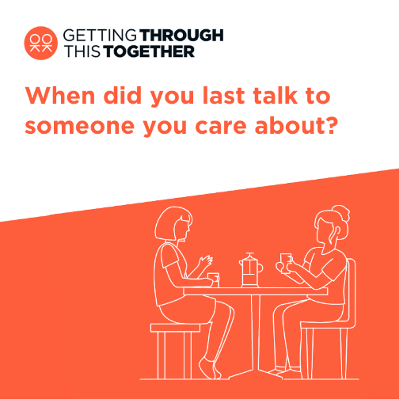  Alt Text: Two people are sat at a table and having a chat over a cup of coffee. The text above them reads: When did you last talk to someone you care about?  More: https://drive.google.com/drive/folders/1Ijzql7UQ0ExvBzc1bRHRQjShXCyRwkuX?usp=share_link
Instagram 2 | Loneliness can affect us all, at any time of our lives.  When times are tough it’s important that we look after our own and each other’s wellbeing.  @ThriveLDN's conversation starter tool gives you the tips and prompts to help you get your community talking about good mental health, wellbeing and financial worries.  This conversation starter tool follows a SIGNSS framework – Situation, Initiate, Guide, Nudge, and Support and Signpost – and aims to help encourage a gentle and supportive conversation.  It is designed to complement what many Londoners are already doing to support those close to them or in their social networks through difficult times.  Follow the link in @ThriveLDN’s bio.  #ThroughTogether  #ZeroSuicideLDN | 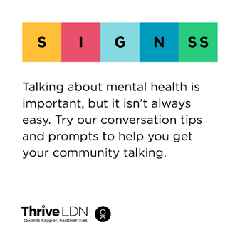  Alt Text: A graphic that highlights the conversation starter tool SIGNSS framework. The text below says “Talking about mental health is important, but it isn’t always easy. Try our conversation tips and prompts to get your community talking.”
Instagram 3 | In these tough times, it's important to look out for those around you.  Remember to check in with friends, family and workmates.  @goodthinkinguk's guides lead you through three simple steps to help if someone you know is struggling - including tips on starting those difficult conversations from @thriveldn and #MentalWellbeing support and resources for you to share.  good-thinking.uk/how-guides/quick-guides-support-others | 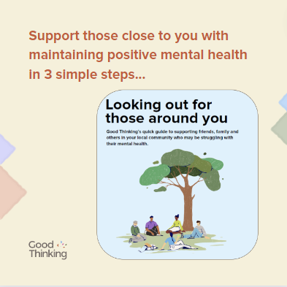  Alt Text: A graphic that highlights the Good Thinking guides to looking out for those around you. The text below says “Support those close to you with maintaining positive mental wellbeing in 3 simple steps”. Illustration of a group of people of various ages and genders sat under a tree.
Instagram 4 | Starting a conversation about mental health with your child can be tough.  @goodthinkinguk's guide leads you through 3 easy steps to help you check in and get them the support they need:  good-thinking.uk/how-guides/quick-guides-support-others  Let them know you are there for them ❤️ | 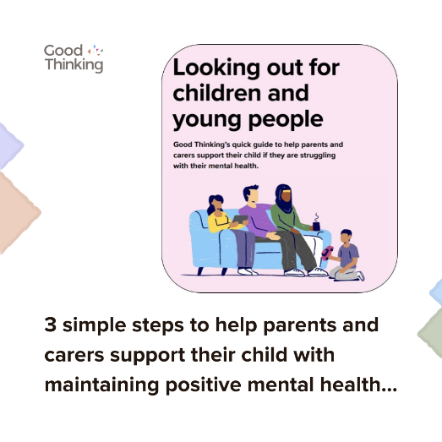  Alt Text: A graphic that highlights the Good Thinking guide for parents and carers to looking out for children and young people. Illustration of a family sat together on a sofa.  Download: https://drive.google.com/drive/u/1/folders/1eegJjVGiRoAULb-uKP4zhwiqdjmsMsTA
Facebook and LinkedIn | When times are tough it’s important that we look after our own and each other’s wellbeing.  @ThriveLDN's updated conversation starter tool gives you the tips and prompts to help you get your community talking about good mental health, wellbeing and financial worries.  This conversation starter tool follows a SIGNSS framework – Situation, Initiate, Guide, Nudge, and Support and Signpost – and aims to help encourage a gentle and supportive conversation.  It is designed to complement what many Londoners are already doing to support those close to them or in their social networks through difficult times.  Explore via Thrive LDN’s website: https://thriveldn.co.uk/communications/toolkits-and-resources/toolkit/thrive-ldn-mental-health-conversation-starter/ | Alt Text: A graphic that highlights the conversation starter tool SIGNSS framework. The text below says “Talking about mental health is important, but it isn’t always easy. Try our conversation tips and prompts to get your community talking.”

