THRIVE LDN COMMS TOOLKIT:
World Suicide Prevention Day 2023
Sunday, 10 September 2023
Updated Thursday, 10 August 2023
In this document (Ctrl + Click on link to go directly to that section):
- Context and introduction

- #ZeroSuicideLDN campaign update and suicide prevention in London

- Digital assets
Download a suite of static and moving graphics to use with our suggested social media copy:
- Google Drive
- As a ZIP file (64MB)

- SUGGESTED COPY: #ZeroSuicideLDN and World Suicide Prevention Day
- For posting on World Suicide Prevention Day - Sunday, 10 September 2023
- For posting any time before or after World Suicide Prevention Day
- For posting on completion of the training (anytime)
- Standard text for newsletters and/or offline copy

- Support with money worries (cost-of-living signposting)
- Suggested social media posts support signposting to relevant services that will support Londoners with money worries.
- Thrive LDN conversation starter
- Thrive LDN’s conversation starter tool helps Londoners engage with friends, family, neighbours or those they support in the community or workplace about good mental health, wellbeing and financial worries. The conversation starter tool is also embedded in the Good Thinking guides to looking out for those around you which have been tailored for children and young people, parents and carers, and employers.
- Free trauma-informed practice training
- Thrive LDN has been working with Nicola Lester Psychological Trauma Consultancy to offer free, online trauma-informed practice training to support individuals and organisations.

Further information/ support
If you’d like support using the graphics or want to chat with the Thrive LDN team about making the suggested copy more relevant to your community/audiences, then please get in touch, e-mail:
James Ludley on james.ludley@nhs.net; info@thriveldn.co.uk.
- Context and introduction
World Suicide Prevention Day (WSPD) takes place annually on 10 September.
It was established in 2003 in conjunction between The International Association for Suicide Prevention (IASP) and the World Health Organisation (WHO). It is a significant advocacy and communication-based event aimed at reaching national organisations, governments and the general public, giving a singular message that suicide can be prevented.
- Find out more general information about the campaign from The International Association for Suicide Prevention (IASP).
- #ZeroSuicideLDN campaign update and suicide prevention in London
Four years ago on World Suicide Prevention Day 2019, a citywide #ZeroSuicideLDN campaign was launched by the Mayor of London and partners to encourage Londoners to access the Zero Suicide Alliance’s free, online suicide prevention training.
The Zero Suicide Alliance is a collaborative of National Health Service trusts, businesses and individuals who are all committed to suicide prevention in the UK and beyond. The alliance is ultimately concerned with improving support for people contemplating suicide by raising awareness of and promoting free suicide prevention training which is accessible to all.
To date, more than 350,000 people across the capital have completed the training supported by the #ZeroSuicideLDN campaign.
This is a fantastic, collective achievement. Thank you to all London partners for continuing to support this campaign.
To mark World Suicide Prevention Day 2023, we’d be grateful if partners would continue to support and share the campaign. The increased cost-of living pressures which emerged over this past year have been significant for many across the city and have had a detrimental impact on Londoners’ mental health and wellbeing. There has never been a more important time to shine a light on the campaign and encourage Londoners to learn how to support those around them who may be in crisis.
Digital assets to support the campaign
In this toolkit you can access the latest campaign assets for digital channels alongside a series of suggested messages for digital and non-digital communications.
We have split this across messages that can be shared in the lead to WSPD, on the day itself and after, to support the ongoing campaign and signposting. We have also included suggested messaging which can be used by anyone who completes the training who may wish to encourage others in their network to do so.
Cost-of-living considerations
Financial resilience and feelings of control relating to finance have a profound impact on people’s wellbeing. Due to the extreme challenges posed by the increases to the cost-of-living more Londoners will be considered vulnerable to suicide.
As such, it remains more important than ever to encourage many more Londoners to play their part in looking out for other Londoners by supporting the #ZeroSuicideLDN campaign.
To support partners, we have also adapted and included some wider signposting in the context of the current emerging challenges for the public mental health response in London, including cost-of-living and accessing NHS urgent mental health support lines.
By thinking and talking more about our mental health, we can break the stigma surrounding suicide and mental health.
- Digital assets
Download #ZeroSuicideLDN resources
Explore a suite of static and moving graphics to use with our suggested social media copy, all resources are also available to download:
- Via Google Drive
- As a ZIP file (64MB)
We have created these in square, wide and tall dimensions to support across mainstream social and digital channels. You can select a graphic of your choice for use when posting the below or for ease, we’ve included some suggested assets for posts (right click, then ‘open link’ to download).
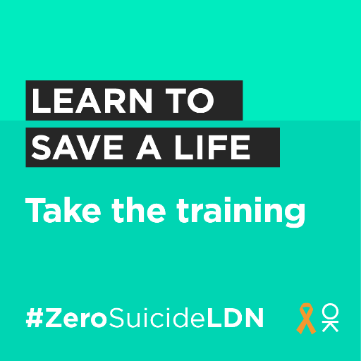 | 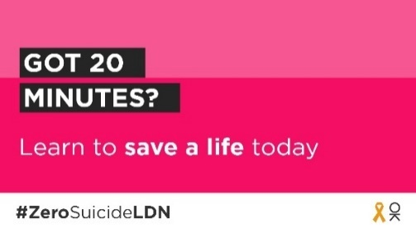 | 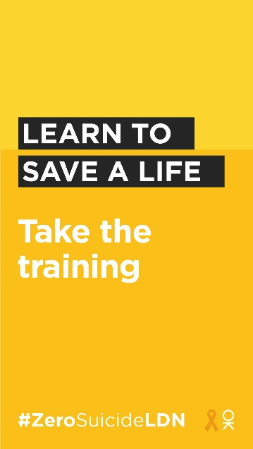
 | 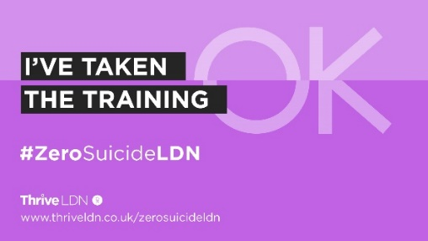
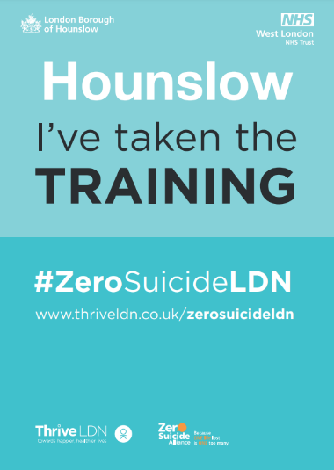
Localising the campaign
Additionally, west London boroughs of Hounslow, Hammersmith and Fulham, and Ealing, in partnership with West London NHS Trust, are marking World Suicide Prevention Day 2023 by sharing the campaign and encouraging those living and working locally to take the training.
We’ve worked with teams in these boroughs to create localised campaign assets and are currently also working on translated versions to reach as many Londoners and communities as possible. See Hounslow example.
If you’d like to find out more about how you can get involved or request ZSA campaign assets for your local borough, area or organisation, then please get in touch at info@thriveldn.co.uk. This may be something that could be utilised beyond World Suicide Prevention Day and developed as part of communications planning for the autumn/ winter.
- Suggested social copy for WSPD
For posting on World Suicide Prevention Day - Sunday, 10 September 2023
Channel | Suggested copy | Example assets and links for more
Twitter (1) | Today is #WorldSuicidePreventionDay and we're supporting the #ZeroSuicideLDN campaign.  Join us and the 350,000+ Londoners who have taken free, online suicide prevention training. Together we can break the stigma surrounding suicide and mental health.  👉 www.thriveldn.co.uk/zerosuicideldn | 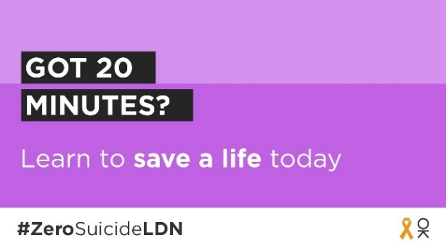  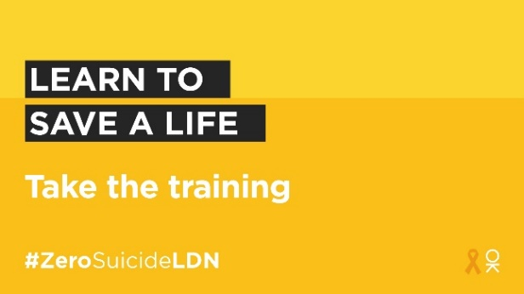  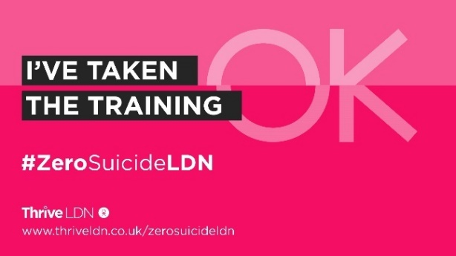  Full range of #ZeroSuicideLDN assets:  Google Drive:  https://drive.google.com/drive/folders/189EzBGDyPA96jr-Tw6-sTIh2egGI_CdE?usp=drive_link  ZIP file:  Download as a ZIP file (64MB).
Twitter (2) | Today is #WorldSuicidePreventionDay.  If you’ve got 20 minutes spare today, then join us in taking the free @Zer0Suicide  online training: http://zerosuicidealliance.com/training  When you’ve completed it, share your certificate and tag us.  Together we can break the stigma and save a life.
Twitter (3) | Today is #WorldSuicidePreventionDay.  Today you can support the #ZeroSuicideLDN campaign by taking free, online training to know what to do if a loved one, colleague or stranger is feeling suicidal.  It only takes 20 minutes. Will you join us?  👉 www.zerosuicidealliance.com/training
Twitter (4) | Today is #WorldSuicidePreventionDay.  Today you can support the #ZeroSuicideLDN campaign by taking free, online training to know what to do if a loved one, colleague or stranger is feeling suicidal.  It only takes 20 minutes. Will you join us?  www.zerosuicidealliance.com/training
Twitter (5) | Around 10 people a week take their own life in London.  This #WorldSuicidePreventionDay you can learn how to save a life with free, online suicide prevention training.  London works best when we look out for each other. Join the #ZeroSuicideLDN campaign: www.thriveldn.co.uk/zerosuicideldn
Twitter (6) | Are you one of the 350,000 Londoners who has completed online free suicide prevention training since the @MayorofLondon launched #ZeroSuicideLDN in 2019?  Help us share the campaign and encourage more Londoners to join us. We can all help save a life.  👉 www.thriveldn.co.uk/zerosuicideldn
Twitter (7) | #WorldSuicidePreventionDay is a good opportunity for us all to remember that a mental health emergency should be taken as seriously as a physical one.  People of all ages needing urgent mental health support can call NHS mental health helplines 24/7.  👉 www.nhs.uk/service-search/mental-health/find-an-urgent-mental-health-helpline | 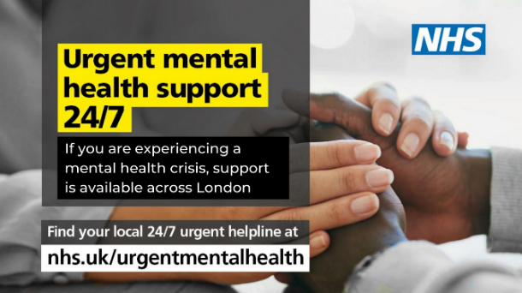  More assets: https://drive.google.com/drive/folders/1Uzap0hlrG9pWEvXuGfSRv_sKimLk5cmP
Instagram | Today for #WorldSuicidePreventionDay we're supporting the #ZeroSuicideLDN campaign with @ThriveLDN and the @zerosuicidealliance.  We know that living and working in London can be stressful, and right now for some it may be overwhelming. That is why we want to encourage Londoners to take free, online training to know what to do if a loved one, colleague or stranger is in crisis.  Together we can break the stigma surrounding suicide and mental health.  Learn to save a life today...  Visit 👉 thriveldn.co.uk/ZeroSuicideLDN  Or find details in @ThriveLDN bio.  #ZeroSuicideLDN  #ThroughTogether  #ThriveLDN  #ZeroSuicideAlliance  #Londoners  #MentalHealth  #London  #LifeInLondon  #WeAreLDN  #OKLDN  #SuicidePrevention  #OnlineTraining | 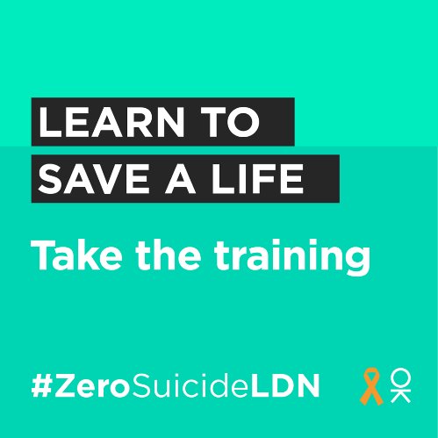  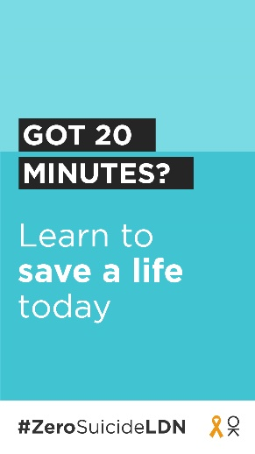  More assets:  https://drive.google.com/drive/folders/189EzBGDyPA96jr-Tw6-sTIh2egGI_CdE?usp=drive_link
Facebook and LinkedIn | Today for #WorldSuicidePreventionDay we're supporting the #ZeroSuicideLDN campaign with Thrive LDN and the Zero Suicide Alliance.  Learn to save a life today...  We know that living and working in London can be stressful, and right now for some it may be overwhelming. That is why we want to encourage Londoners to take free, online training to know what to do if a loved one, colleague or stranger is in crisis.  Visit 👉 www.thriveldn.co.uk/ZeroSuicideLDN  Together we can break the stigma surrounding suicide and mental health. | More assets:  https://drive.google.com/drive/folders/189EzBGDyPA96jr-Tw6-sTIh2egGI_CdE?usp=drive_link
LinkedIn  For individuals, can be adapted for other channels | Today is #WorldSuicidePreventionDay.  I’ve just taken free, online suicide prevention training.  It’s never been more important to think and talk more about mental health. The Zero Suicide Alliance’s free suicide prevention training is a really helpful way to learn what to do if a loved one, colleague, or stranger is in a crisis or at risk of suicide.  Learn to save a life today, join me in supporting the #ZeroSuicideLDN campaign.  Join me and take the training now: https://zerosuicidealliance.com/training  Or visit Thrive LDN’s website for more details about the #ZeroSuicideLDN campaign: www.thriveldn.co.uk/zerosuicideldn | More assets:  https://drive.google.com/drive/folders/189EzBGDyPA96jr-Tw6-sTIh2egGI_CdE?usp=drive_link

For posting any time before or after World Suicide Prevention Day
Channel | Suggested copy | Example assets and links for more
Twitter (1) | We all need to look out for one another. That's why we are supporting #ZeroSuicideLDN to encourage everyone to take free, online training to know what to do if a loved one, colleague, or stranger is in crisis.  Learn to save a life today...  Visit 👉 www.thriveldn.co.uk/ZeroSuicideLDN | Full range of #ZeroSuicideLDN assets:  Google Drive:  https://drive.google.com/drive/folders/189EzBGDyPA96jr-Tw6-sTIh2egGI_CdE?usp=drive_link  ZIP file:  Download as a ZIP file (64MB).
Twitter (2) | It’s never been more important to think and talk more about mental health. That’s why we are taking @Zer0Suicide’s free suicide prevention training, to learn what to do if a loved one, colleague, or stranger is at risk of suicide.  You can too. Visit 👉 https://zerosuicidealliance.com/training
Twitter (3) | Some people may be finding life harder than usual at the moment. It's vital we all look out for each other, in case someone may be in crisis.  That's why we are supporting the #ZeroSuicideLDN campaign. You can too, it only takes 20 minutes.  Visit 👉 www.thriveldn.co.uk/zerosuicideldn
Twitter (4) | London works best when we all work together and look after each other. 🧡  There's FREE online 20-minute training available to help us all to spot the signs when someone may be thinking about taking their life.  Visit https://zerosuicidealliance.com/training  #ZeroSuicideLDN
Twitter (5) | For some Londoners right now, worries over money or debt may be overwhelming. Would you be able to spot a neighbour or friend in distress? There’s FREE @Zer0Suicide online training to help.  Visit https://zerosuicidealliance.com/training  #ZeroSuicideLDN
Twitter (6)  Witness to suicide resource and support | First Hand has been developed by @ThriveLDN, @AfterSuicideUK and @GrassrootsSP to support anyone who has witnessed the suicide of someone they do not know.  If this is you, please know that there is help and support available. You are not alone 🧡  https://supportaftersuicide.org.uk/resource/first-hand/ | 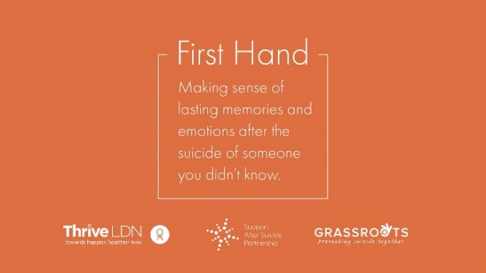  Right click to download
Twitter (9)  NHS urgent mental health support lines signposting | Life can be really difficult, and you might sometimes feel completely overwhelmed. But remember, a mental health emergency should be taken as seriously as a physical one.  Find your local NHS urgent mental health helpline for 24/7 advice and support.  👉 www.nhs.uk/service-search/mental-health/find-an-urgent-mental-health-helpline | 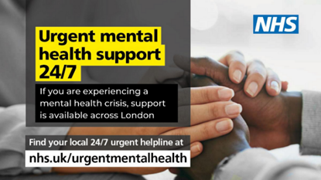  More assets: https://drive.google.com/drive/folders/1P35u0hUFqd2LTKYM6ThatE1SMA2EoHIB
Instagram | Have you got 20 minutes to learn how to save a life today?  Around 10 people a week take their own life in London. We want to encourage Londoners to take the FREE online training provided by the @zerosuicidealliance so they know what to do if a loved one, colleague or stranger is in crisis.  Learn to save a life today...take the training.  Visit 👉 thriveldn.co.uk/zerosuicideldn  Or find details in @ThriveLDN bio.  #ZeroSuicideLDN  #ThroughTogether | 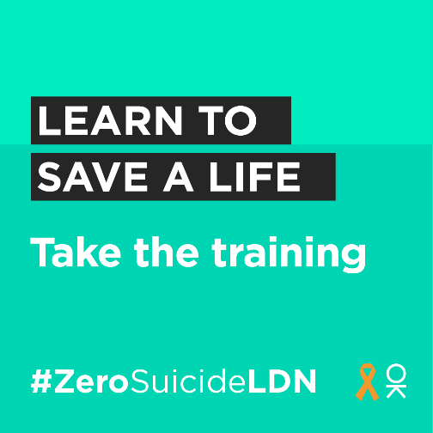  More assets: https://drive.google.com/drive/u/0/folders/189EzBGDyPA96jr-Tw6-sTIh2egGI_CdE
Facebook and LinkedIn | Living and working in London can be stressful, and right now for some it may be overwhelming. Would you be able to spot a colleague or friend in distress?  That is why we want to encourage Londoners to take the Zero Suicide Alliance’s free, online training to know what to do if a loved one, colleague or stranger is in crisis.  Learn to save a life today...take the training. Visit: www.thriveldn.co.uk/zerosuicideldn | 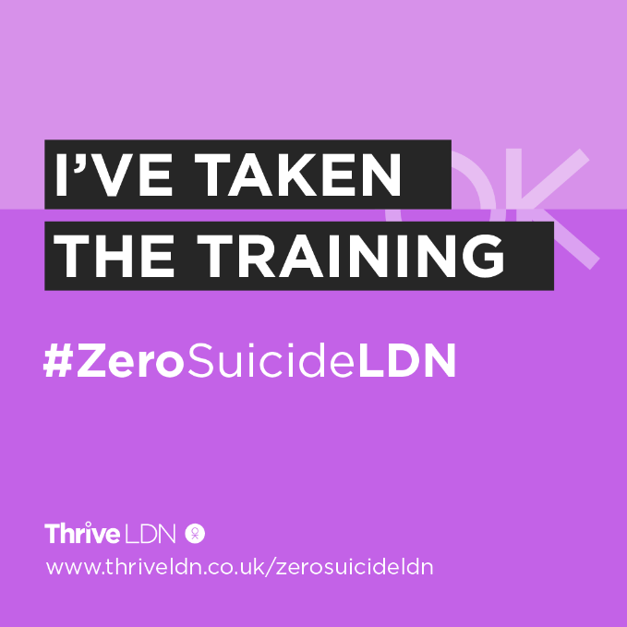  More assets: https://drive.google.com/drive/u/0/folders/189EzBGDyPA96jr-Tw6-sTIh2egGI_CdE
LinkedIn (for individuals) | I’ve taken suicide prevention training.  It’s never been more important to think and talk more about mental health. The Zero Suicide Alliance’s free suicide prevention training is a really helpful way to learn what to do if a loved one, colleague, or stranger is in a crisis or at risk of suicide.  Learn to save a life today, join me in supporting the #ZeroSuicideLDN campaign.  Visit Thrive LDN’s website for more details: www.thriveldn.co.uk/zerosuicideldn | 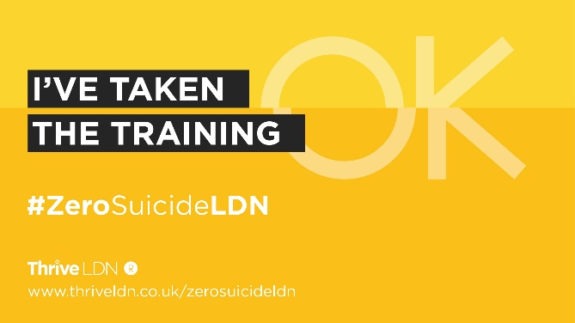  More assets:  https://drive.google.com/drive/u/4/folders/1ywBx_uVXKPh4AXorsQJqBCzyy4lKpxSc

For posting on completion of the training – anytime
Channel | Suggested copy | Example assets and links for more
Twitter (1) | I’ve just taken @Zer0Suicide’s free suicide prevention training.  Join me and the 350,000+ Londoners to learn how to support a loved one, colleague or stranger in crisis. Together we can break the stigma surrounding suicide and mental health.  👉 https://zerosuicidealliance.com/training | 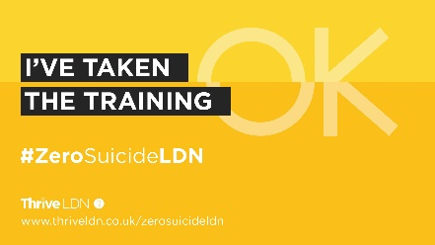  Full range of assets for these posts:  https://drive.google.com/drive/folders/1Vh8ybduMWhBX_Cb35LEOq4NdpGVqWfG5
Twitter/ Linkedin (2) | It’s never been more important to think and talk more about mental health.  That’s why I’ve taken Zero Suicide Alliance’s free suicide prevention training to learn how to support someone in crisis.  It only takes 20 minutes. Will you join me?  👉 https://zerosuicidealliance.com/training
Twitter/ Linkedin (3) | Around 10 people a week take their own life  in London.  It only takes 20 minutes to take Zero Suicide Alliance’s free suicide prevention training to learn how to save a life.  I’ve taken the training. Will you?  www.thriveldn.co.uk/zerosuicideldn
Twitter/ Linkedin (4) | Got 20 minutes? Why not use it to learn how to save a life?  I’ve just completed Zero Suicide Alliance’s training to learn how to support someone who may be in crisis.  Join me and learn to save a life today  www.thriveldn.co.uk/zerosuicideldn
Facebook LinkedIn/ | I’ve taken suicide prevention training.  It’s never been more important to think and talk more about mental health. The Zero Suicide Alliance’s free suicide prevention training is a really helpful way to learn what to do if a loved one, colleague, or stranger is in a crisis or at risk of suicide.  Learn to save a life today, join me in supporting the #ZeroSuicideLDN campaign.  Visit Thrive LDN’s website for more details: www.thriveldn.co.uk/zerosuicideldn | More assets:  https://drive.google.com/drive/folders/189EzBGDyPA96jr-Tw6-sTIh2egGI_CdE?usp=drive_link
Instagram | I’ve taken @zerosuicidealliance’s free, suicide prevention training to support the #ZeroSuicideLDN campaign.  It’s never been more important to think and talk more about mental health. The training only takes 20 minutes and is a really helpful way to learn what to do if a loved one, colleague, or stranger is in a crisis or at risk of suicide.  Together we can break the stigma surrounding suicide and mental health.  Join me and learn to save a life today...  Visit 👉 thriveldn.co.uk/zerosuicideldn  Or find details in @ThriveLDN bio. | 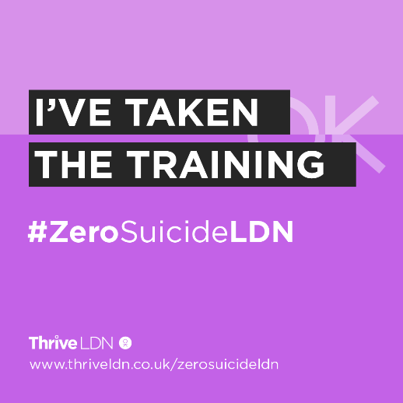  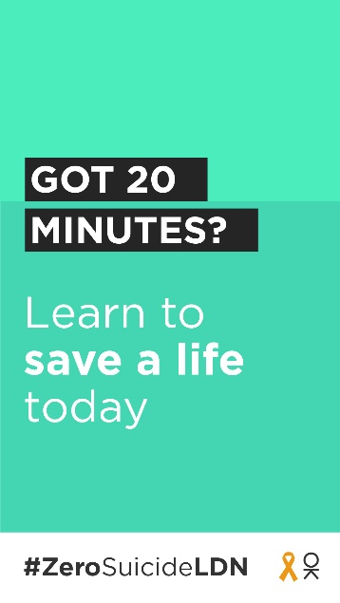  More assets:  https://drive.google.com/drive/folders/189EzBGDyPA96jr-Tw6-sTIh2egGI_CdE?usp=drive_link

Standard text for newsletters and/or offline copy
This standard text can be adapted for websites, e-newsletters and other bulletins. Localise and adapt text in red.
Website copy  525 words | More than 350,000 Londoners have accessed suicide prevention training as part of the #ZeroSuicideLDN campaign  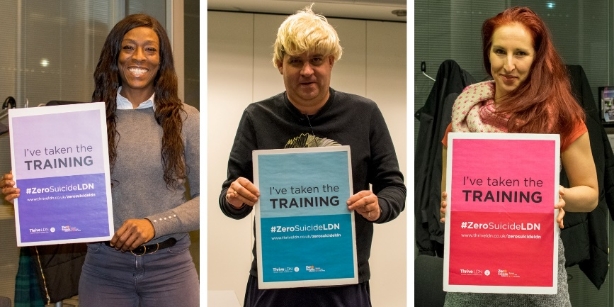  [Right click to download image. Alt text: Londoners showing their support for the #ZeroSuicideLDN campaign.]  Suicide is the leading cause of death in people aged 15–29, and the biggest killer of men under 49 in the UK. In London, the sad truth is suicide is the cause of death of around 10 Londoners every week.  Launched in September 2019, the citywide #ZeroSuicideLDN campaign has seen more than 350,000 people across the capital access free, online suicide prevention training.  Developed by the Zero Suicide Alliance, the free, online training takes around 20 minutes to complete and is designed to show how to have a direct and honest conversation about suicide and mental health with friends and family. The training also helps to break the stigma of talking about mental health, suicidal thoughts and bereavement.  Marking World Suicide Prevention Day 2023, campaign organisers are highlighting how ‘it is now more important than ever’ to encourage many more Londoners to play their part in looking out for other Londoners.  Debt is a significant risk factor of suicide and many Londoners continue to face a challenging and uncertain time due to increased cost-of-living pressures, which are being felt unevenly across London. Financial concerns are not always commonly discussed. People may feel a sense of shame about their situation or do not typically discuss personal finance with others.  More than one in three UK adults (36 per cent) surveyed by the charity Mind said they never make space in their day or the time to speak about their mental health. Yet nearly 8 in 10 who responded (78 per cent) said that their mental health has been affected by cost-of-living crisis – this was worse for those with existing mental health problems (94 per cent).  [Local spokesperson] said: “[Organisation/Borough] supports the #ZeroSuicideLDN campaign and we want to help it go even further.  “World Suicide Prevention Day is an opportunity to remember that it has never been more important for each of us to think and talk more about mental health and wellbeing.  Please take the free 20-minute online training and then tell your friends, colleagues, and family about it too. Together, by encouraging even more Londoners to take the Zero Suicide Alliance’s free online training, we can support people to talk openly about suicide and mental health.”  Dr Jacqui Dyer MBE, mental health equalities advisor for NHS England and co-lead of Thrive LDN, said: “We know that living and working in London can be stressful, and right now for some it may be overwhelming. That is why we want to encourage as many people as possible to take free, online training to know what to do if a loved one, colleague or stranger is in crisis.  “By doing so, we are working towards a city that is stigma free, where people can have a more direct and honest conversation about suicide with fellow Londoners in a safe and sensitive way. Especially considering the challenges so many Londoners have faced due to the pandemic and more recently increased cost-of-living pressures.”  To find out more about these resources and the suicide prevention training, visit www.thriveldn.co.uk/zerosuicideldn.
Newsletter copy  113 words | This World Suicide Prevention Day take free, online training and be prepared to save a life  We know that living and working in London can be stressful, and right now for some it may be overwhelming considering the many challenges so many Londoners face.  That is why we want to encourage Londoners to support the #ZeroSuicideLDN campaign and take free, online training to know what to do if a loved one, colleague or stranger is in crisis.  World Suicide Prevention Day is an opportunity to remember that it has never been more important for each of us to think and talk more about mental health and wellbeing. For full details visit: www.thriveldn.co.uk/zerosuicideldn.

- Support with money worries (cost-of-living signposting)
We are encouraging partners to signpost to information on how to manage financial anxiety and uncertainty, alongside resources which support mental health and wellbeing.
The below suggested social media posts support signposting to relevant services that will support Londoners with money worries. The GLA has published a Help With the Cost of Living online hub which contains a range of information to support Londoners, including on money and mental health.
Please consider incorporating these alongside any other planned communications on this topic/ area or when aligning with suicide prevention communications.
In summary:
- Financial resilience and feelings of control relating to finance have a profound impact on people’s wellbeing.
- Employment and financial security have a two-way relationship with overall mental health, with stable, consistent employment and the ability to save money act as protectors of mental health whereas debt, unemployment, and financial instability act as some of the main barriers to emotional wellbeing.
- The challenges posed by the cost-of-living crisis are being felt unevenly across London, exposing differences of vulnerability across geographies and social groups. As such, more Londoners will be considered vulnerable to suicide.
- In response to this it is vital for London to take a public mental health approach to its response to ensure that the wellbeing of Londoners is prioritised alongside the growth of London’s economy.
Support with money worries (below links could be localised)
Channel | Suggested copy | Example assets and links for more
Twitter – Debt Free Advice | For some Londoners right now, worrying about money may feel overwhelming or leaving you feeling very anxious.  If you are worried about money or need free, impartial advice, @DebtFreeAdvice_’s advice line is there to help.  Call 0800 808 5700 or visit www.debtfreeadvice.com | 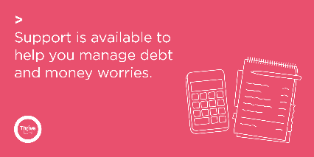  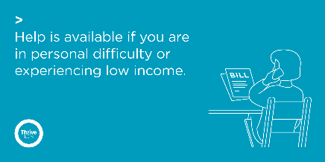
Twitter – supporting debt and money worries 1 | For some Londoners right now, worries over money or debt may be overwhelming.  If you are worried about money or need impartial advice, there is support available. Ask for help if you need it.  @DebtFreeAdvice_ 0800 808 5700  @CAPuk 0800 328 0006  Or visit www.nhs.uk/mental-health/advice-for-life-situations-and-events/how-to-cope-with-financial-worries/
Twitter – supporting debt and money worries 2 | Talking about financial concerns and difficulties is challenging. But you are not alone, and there is nothing to be ashamed of.  Talk to someone you trust💬  Reach out to friends and family🤝  If you need advice there is support available: www.london.gov.uk/what-we-do/communities/help-cost-living/help-if-money-worries-are-affecting-your-mental-health  #ThroughTogether
Twitter – supporting debt and money  worries 3 | Accessing help and support for financial difficulties is really important. And doing what you can to stay well will help you deal with things better.  Talk to someone you trust 💬  Take things one step at a time ☝️  Focus on what you can control 👤  Reach out to friends & family 🤝
Twitter – personal difficulty | If you find yourself in urgent financial or personal need, there is support and information available for you. Please seek help if you need it.  💷 @turn2us_org: 0808 802 2000  🏘️ @Shelter: 0344 515 1540  🥫 @TrussellTrust: 0808 208 2138  Or visit www.london.gov.uk/what-we-do/communities/help-cost-living/
Twitter – Good Thinking resources | If you’re feeling the strain financially and things seem overwhelming, you can take small steps to help you stay mentally healthy.  @GoodThinkingUK has lots of practical tips and links to organisations that can help ease the pressure: www.good-thinking.uk/articles/cost-living-crisis-how-look-after-your-mental-health  #ThroughTogether | 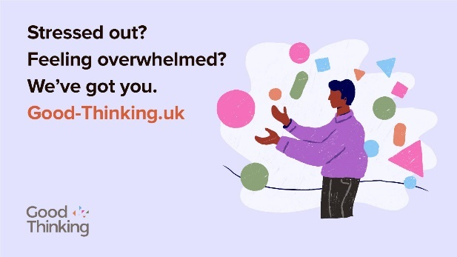  Find relevant Good Thinking assets:  https://drive.google.com/drive/folders/1A-QcbmAUo1Rbxi6IUAS8kYGzBxUlZm3Z
Instagram | For some Londoners right now, worrying about money may feel overwhelming or leaving you feeling very anxious.  If you are worried about money or need free, impartial advice, @debtfreeadvice’s advice line is there to help.  Call 0800 808 5700 or visit debtfreeadvice.com  If you find yourself in urgent financial or personal need, there is support and information available for you. Please seek help if you need it.  💷 @turn2us_org: 0808 802 2000  🏘️ @sheltercharity: 0344 515 1540  🥫 @trusselltrust: 0808 208 2138  Find more advice by searching ‘GLA Cost of Living Hub’. | 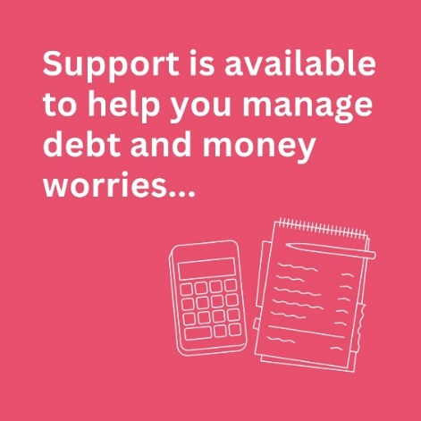  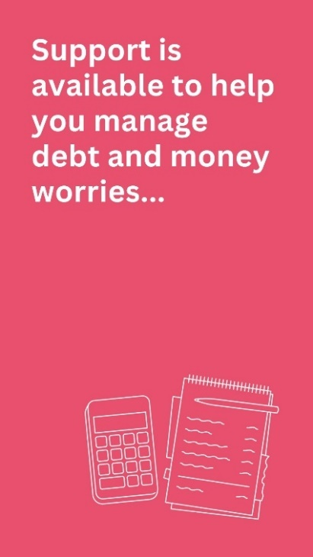
Instagram | Talking about financial concerns and difficulties is challenging. But you are not alone and there is nothing to be ashamed of.  If you need support and impartial advice, there are free professional services available.  Accessing help and support for financial difficulties is really important. But so is also doing what you can to stay well, which will help you deal with things better.  Talk to someone you trust 💬  Take things one step at a time ☝️  Focus on what you can control 👤  Reach out to friends and family 🤝  For a range of information to support Londoners, including on money and mental health, search ‘GLA help with the cost of living online hub’.  And for more ideas on looking after your own wellbeing, @ThriveLDN has simple tools, ideas and inspiration. Follow the link in their bio.  #ThroughTogether
Facebook / LinkedIn | For some Londoners right now, worrying about money may feel overwhelming or leaving you feeling very anxious.  If you are worried about money or need free, impartial advice is available. Debt Free Advice is there to help.  Call free on 0800 808 5700 or visit: www.debtfreeadvice.com  The GLA has published a Help With the Cost of Living online hub which contains a range of information to support Londoners, including on money and mental health: https://www.london.gov.uk/what-we-do/communities/help-cost-living
Facebook / LinkedIn | Talking about financial concerns and difficulties is challenging. But you are not alone and there is nothing to be ashamed of.  If you need support and impartial advice, there are free professional services available.  Accessing help and support for financial difficulties is really important. But so is also doing what you can to stay well, which will help you deal with things better.  Talk to someone you trust 💬  Take things one step at a time ☝️  Focus on what you can control 👤  Reach out to friends and family 🤝  The GLA’s Help With the Cost of Living online hub contains a range of information to support Londoners, including on money and mental health: https://www.london.gov.uk/what-we-do/communities/help-cost-living
- Thrive LDN conversation starter
Thrive LDN’s conversation starter tool helps Londoners engage with friends, family, neighbours or those they support in the community or workplace about good mental health, wellbeing and financial worries. As well as importantly knowing the most appropriate help and advice services to signpost to for professional support.
Download the conversation starter resource (PDF):
- Cost-of-living version (November 2022)
- Covid version (January 2021)

The conversation starter tool is also embedded in the Good Thinking guides to looking out for those around you. Four tailored guides with three simple steps to help you spot the signs of poor mental health in others, check in and let them know you care and help them get the support they need.
Download the guides (PDF):
- Looking out for those around you
- Looking out for friends and colleagues at work
- Looking out for your friends – a guide to help children and young people support friends
- Looking out for children and young people – a guide for parents and carers

Channel | Suggested post | Suggested asset
Twitter 1 | Talking about mental health is important, but it isn’t always easy.  Explore @ThriveLDN's conversation starter tool to find tips and prompts to help you get your community talking.  https://thriveldn.co.uk/communications/toolkits-and-resources/toolkit/thrive-ldn-mental-health-conversation-starter/ | 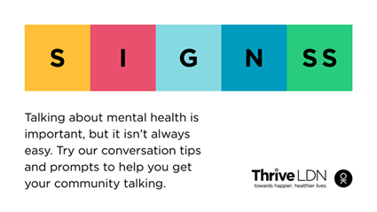  Alt Text: A graphic that highlights the conversation starter tool SIGNSS framework. The text below says “Talking about mental health is important, but it isn’t always easy. Try our conversation tips and prompts to get your community talking.”  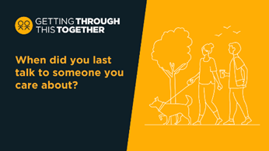  Alt Text: Two people are walking a dog in an open green space and havening a chat. The text above them reads: When did you last talk to someone you care about?  More: https://drive.google.com/drive/folders/16eX6qdbW0L9d5I-rnS2Lk7DVKvJhoFhl?usp=share_link
Twitter 2 | It’s not always easy for someone to talk about how they’re feeling or share their concerns.  Why not reach out to a friend or loved one to get them talking.  Explore some ways in which you can start such conversations: www.thriveldn.co.uk/communications/toolkits-and-resources/toolkit/thrive-ldn-mental-health-conversation-starter/
Twitter 3 | Reaching out to someone could help them know that someone cares and help them find the support they need.  Explore @ThriveLDN’s tips on having a supportive conversation: thriveldn.co.uk/communications/toolkits-and-resources/toolkit/thrive-ldn-mental-health-conversation-starter/
Twitter 4 | In these tough times, it's important to look out for those around you.  Remember to check in with friends, family and workmates.  @GoodThinkingUK's guides lead you through 3 easy steps to help if someone you know is struggling: https://www.good-thinking.uk/how-guides/quick-guides-support-others | 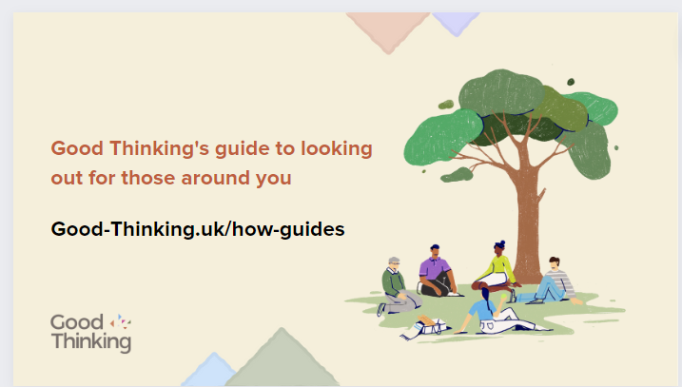  Alt Text: A graphic that highlights the Good Thinking guides to looking out for those around you. The text below says “Good Thinking’s guide to looking out for those around you” and includes a link to access the guides, “good-thinking.uk/how-guides”. Illustration of a group of people of various ages and genders sat under a tree.  Download: https://drive.google.com/drive/u/1/folders/1eegJjVGiRoAULb-uKP4zhwiqdjmsMsTA
Twitter 5 | Starting a conversation about mental health with your child can be tough.  @GoodThinkingUK's guide leads you through 3 easy steps to help you check in and get them the support they need: https://www.good-thinking.uk/how-guides/quick-guides-support-others  Let them know you are there for them ❤️ | 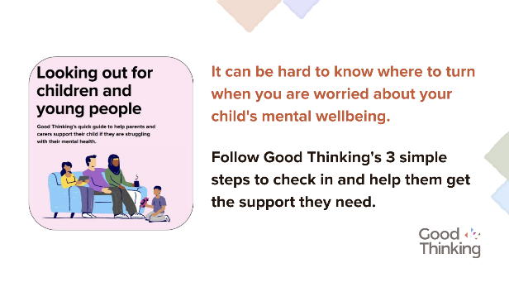  Alt Text: A graphic that highlights the Good Thinking guide for parents and carers to looking out for children and young people. Illustration of a family sat together on a sofa.  Download: https://drive.google.com/drive/u/1/folders/1eegJjVGiRoAULb-uKP4zhwiqdjmsMsTA
Instagram 1 | When times are tough, it’s important that we look after our own and each other's wellbeing.  Reaching out to someone could help them know that someone cares, that they are valued, and help them find the support they need.  Explore @ThriveLDN’s tips on having a supportive conversation - click the link in their bio. | 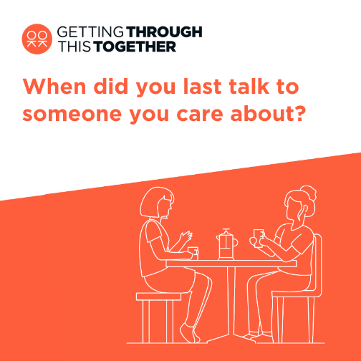  Alt Text: Two people are sat at a table and having a chat over a cup of coffee. The text above them reads: When did you last talk to someone you care about?  More: https://drive.google.com/drive/folders/1Ijzql7UQ0ExvBzc1bRHRQjShXCyRwkuX?usp=share_link
Instagram 2 | Loneliness can affect us all, at any time of our lives.  When times are tough it’s important that we look after our own and each other’s wellbeing.  @ThriveLDN's conversation starter tool gives you the tips and prompts to help you get your community talking about good mental health, wellbeing and financial worries.  This conversation starter tool follows a SIGNSS framework – Situation, Initiate, Guide, Nudge, and Support and Signpost – and aims to help encourage a gentle and supportive conversation.  It is designed to complement what many Londoners are already doing to support those close to them or in their social networks through difficult times.  Follow the link in @ThriveLDN’s bio.  #ThroughTogether  #ZeroSuicideLDN | 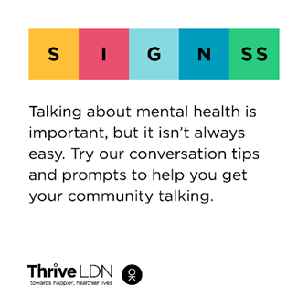  Alt Text: A graphic that highlights the conversation starter tool SIGNSS framework. The text below says “Talking about mental health is important, but it isn’t always easy. Try our conversation tips and prompts to get your community talking.”
Instagram 3 | In these tough times, it's important to look out for those around you.  Remember to check in with friends, family and workmates.  @goodthinkinguk's guides lead you through three simple steps to help if someone you know is struggling - including tips on starting those difficult conversations from @thriveldn and #MentalWellbeing support and resources for you to share.  good-thinking.uk/how-guides/quick-guides-support-others | 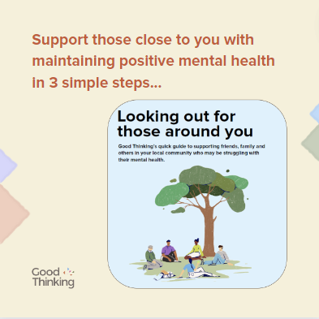  Alt Text: A graphic that highlights the Good Thinking guides to looking out for those around you. The text below says “Support those close to you with maintaining positive mental wellbeing in 3 simple steps”. Illustration of a group of people of various ages and genders sat under a tree.
Instagram 4 | Starting a conversation about mental health with your child can be tough.  @goodthinkinguk's guide leads you through 3 easy steps to help you check in and get them the support they need:  good-thinking.uk/how-guides/quick-guides-support-others  Let them know you are there for them ❤️ | 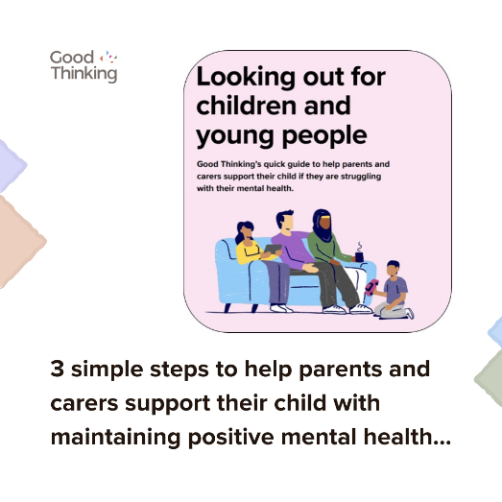  Alt Text: A graphic that highlights the Good Thinking guide for parents and carers to looking out for children and young people. Illustration of a family sat together on a sofa.  Download: https://drive.google.com/drive/u/1/folders/1eegJjVGiRoAULb-uKP4zhwiqdjmsMsTA
Facebook and LinkedIn | When times are tough it’s important that we look after our own and each other’s wellbeing.  @ThriveLDN's updated conversation starter tool gives you the tips and prompts to help you get your community talking about good mental health, wellbeing and financial worries.  This conversation starter tool follows a SIGNSS framework – Situation, Initiate, Guide, Nudge, and Support and Signpost – and aims to help encourage a gentle and supportive conversation.  It is designed to complement what many Londoners are already doing to support those close to them or in their social networks through difficult times.  Explore via Thrive LDN’s website: https://thriveldn.co.uk/communications/toolkits-and-resources/toolkit/thrive-ldn-mental-health-conversation-starter/ | Alt Text: A graphic that highlights the conversation starter tool SIGNSS framework. The text below says “Talking about mental health is important, but it isn’t always easy. Try our conversation tips and prompts to get your community talking.”

- Free trauma-informed practice training
Thrive LDN has been working with Nicola Lester Psychological Trauma Consultancy to offer free, online trauma-informed practice training to support individuals and organisations.
The training is offered across three levels, Bronze, Silver and Gold. At each level, participants receive a certificate of completion and certified badge which can be used to demonstrate their knowledge and trauma informed training status. Training is free to complete and does not require registration to join.
More details including the links to the courses can be found on the Thrive LDN website.
Below we have provided some suggested copy for digital channels which you may find useful to promote the training opportunity to your networks, internally and externally.
Whilst the training videos can be accessed individually, some organisations may prefer to participate in a group, either in person or online. On our website, you can also find a brief guide for facilitators to promote engagement and enhance opportunities for discussion and sharing learning.
Channel | Suggested post | Suggested asset
Twitter (1) | #TraumaInformed training: @ThriveLDN has been working with Nicola Lester to offer free, pre-recorded online trauma-informed practice training to support individuals and organisations. Available at Bronze, Silver & Gold levels.  Training and supporting resources can be accessed via: www.thriveldn.co.uk/trauma-informed | Video:  Static:  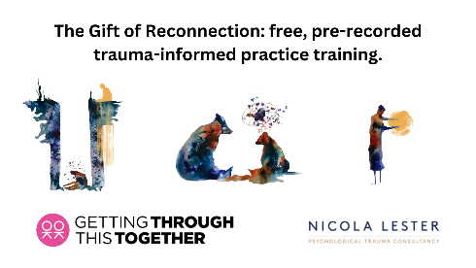  Download all digital assets.
Twitter (2) | Interested in becoming more trauma aware?  Then take @ThriveLDN and Nicola Lester’s free, online training and get certified at bronze, silver and gold level.  Full details about the training and supporting resources can be accessed via: www.thriveldn.co.uk/trauma-informed  #ThroughTogether
LinkedIn and Facebook | How trauma aware are you?  Thrive LDN has partnered with Nicola Lester Psychological Trauma Consultancy to offer free, pre-recorded online trauma-informed practice training to support individuals and organisations.  The training is offered across three levels, Bronze, Silver and Gold, with the opportunity to move up to the next level at each stage.  At each level, participants will receive a certificate of completion and certified badge which can be used to demonstrate their knowledge and trauma informed training status.  Training is free to complete and can be accessed from @ThriveLDN’s website:  www.thriveldn.co.uk/trauma-informed
Instagram | How trauma aware are you?  @ThriveLDN has partnered with Nicola Lester Psychological Trauma Consultancy to offer free, pre-recorded online trauma-informed practice training to support individuals and organisations.  The training is offered across three levels, Bronze, Silver and Gold, with the opportunity to move up to the next level at each stage.  At each level, participants will receive a certificate of completion and certified badge which can be used to demonstrate their knowledge and trauma informed training status.  Training is free to complete and can be accessed from @ThriveLDN’s website:  www.thriveldn.co.uk/trauma-informed  Or search the link in their bio.  #TraumaInformed  #MentalHealthTraining  #ThroughTogether | Download all digital assets.  