THRIVE LDN COMMUNICATIONS TOOLKIT: Thrive LDN X Messages of Hope collaboration
Context and introduction
Thrive LDN has been working with Messages of Hope campaign to launch a new collaboration as part of the Getting Through This Together campaign which aims to encourage Londoners to come together and support those around them that may be having a difficult time.
The collaboration will see anonymous messages submitted by Londoners shared through a new Instagram account @throughtogether to encourage the conversation around mental health and help to break the stigma that surrounds it. As well as highlighting professional and urgent support available for anyone that may need it.
We would be grateful for support from London partners to help activate and amplify this new collaboration and phase of the Getting Through This Together campaign.
This toolkit and the launch assets aims to support colleagues to do this.
Launching @Throughtogether on Instagram
This next stage in this ongoing collaboration will see crowdsourced messages shared primarily to Instagram, encouraging Londoners to come together and support those around them that may be having a difficult time.
It gives Londoners an opportunity to connect and engage with messages written by those living and working in the city with lived experience, helping to break the stigma that still surrounds conversations about mental health.
Launched via the @ThroughTogether Instagram account, Londoners’ messages will be scheduled to post daily. There are literally 100s of messages to share so we anticipate this collaboration will be in place for the next 12 months at least. To explore the messages and support the campaign you can follow the account.
Most posts are simple, positive messages of encouragement and togetherness. However, the Thrive LDN team has worked to filter those which relate more to recovery or more serious mental health experiences and those posts will be accompanied by signposting to appropriate mental health and wellbeing services. The link in the bio will also support this, as well as advice on how to get help urgently for those that may need it.
Aims and our ask of partners
- To share and spread the messages received anonymously from Londoners since World Mental Health Day 2022 in a more meaningful way.
- To encourage conversations around mental health and wellbeing among Londoners and help break down the stigma that surrounds it.
- Creating a platform for the sharing of messages that are there for people who may need to find inspiration or positivity from others.
- To encourage Londoners to come together and support those around them that may be having a difficult time.
- To encourage Londoners to engage with Thrive LDN and wider partners’ support offers.
Following an initial collaboration between Thrive LDN and Messages of Hope for World Mental Health Day 2022, hundreds of anonymous messages were collected from Londoners both online and on the day at London’s City Hall as part of the Never Alone LDN festival.
The Thrive LDN X Messages of Hope collaboration forms part of the wider Messages of Hope campaign, created by founder Beth Evans in 2020 as a result of her own personal mental health journey.
Supporting the campaign
The success of this campaign is reliant upon the sharing and amplification of the messages of hope submitted by Londoners. Many of the messages submitted are from those with lived experience of poor mental health and it is the hope that they will reach and support others who may be experiencing a difficult time.
Partners can support the activation of the campaign by:
- Following the @ThroughTogether account on Instagram ahead of the official launch on Monday, 15 May and reshare the pinned ‘about’ post.
- Separately, using the suggested social media copy and launch assets below you can help share the @ThroughTogether account from your own social media channels.
- Resharing campaign assets posted on social media from the @ThroughTogether account.
- Organically using some example launch assets which will be used as part of the launch. Find these below.
- Letting local organisations and community groups in your networks or area know about the Thrive LDN x Messages of Hope collaboration and encourage them to support it. We have offered some suggest newsletter and website copy below.
- You can subscribe to our regular updates and encourage others to do the same.

Suggested messaging for social media
To support the Thrive LDN X Messages of Hope collaboration, we have developed suggested messaging for digital and social media channels. Please consider incorporating the below alongside any other planned communications.

Thrive LDN X Messages of Hope collaboration
Channel | Suggested post | Assets (all launch assets here)
Instagram | London works best when we all look out for each other.  A new collaboration from @Thrive LDN and @messagesof.hope will see anonymous messages from Londoners shared daily to spread hope, togetherness and break the stigma around mental health.  Follow @ThroughTogether to find out more.  #ThroughTogether | 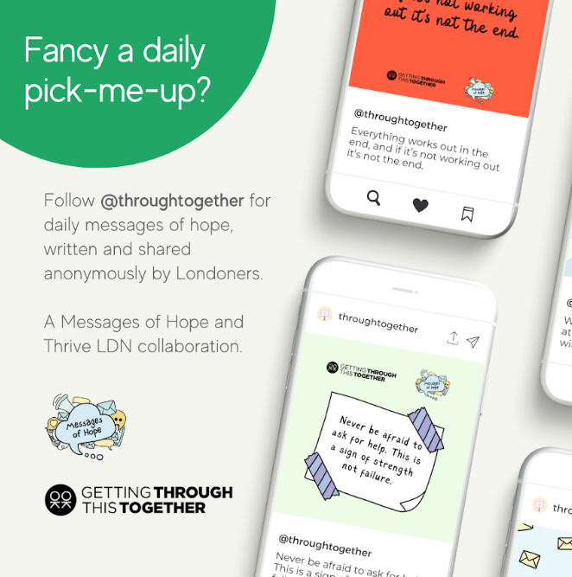  https://drive.google.com/file/d/1FCPoeyX-OXQ9NMxPrWs_yUqBlAg8Qd3B/view?usp=share_link
Instagram | London works best when we are all on each other’s side.  A new collaboration from Thrive LDN and Messages of Hope is asking Londoners to explore the anonymous messages of hope, advice and encouragement shared by fellow Londoners.  Follow @ThroughTogether to find out how you can get involved.  #ThroughTogether | 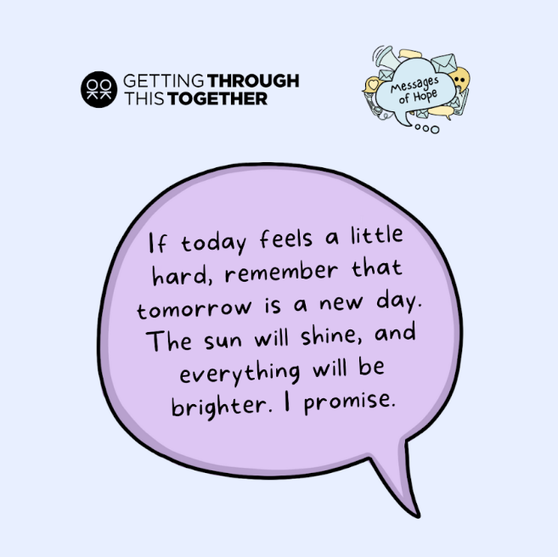  https://drive.google.com/file/d/1KVPCwuY_cO1XKLjovRNAiMn9mFgmhfb1/view?usp=share_link
Instagram | It’s OK to not feel OK during challenging times.  New collaboration @ThroughTogether has received hundreds of messages from Londoners sharing hope, advice and encouragement for anyone that might be struggling.  To find out more follow @ThroughTogether and receive a daily pick-me-up in doing so.  #ThroughTogether | 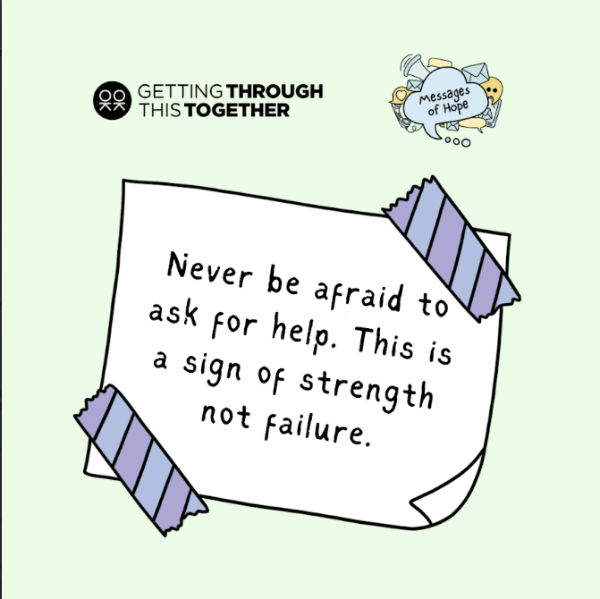  https://drive.google.com/file/d/1HXQtf1B3GbnTC73KvJjJ66MGPP4q9fA4/view?usp=share_link
Instagram | An exciting new collaboration from @ThriveLDN and @messagesof.hope will see Londoners’ messages of hope, advice and encouragement shared daily on social media.  The collaboration aims to encourage conversations around mental health and wellbeing among Londoners, as well as provide support to those that may be struggling right now.  Hundreds of anonymous messages have been submitted from Londoners, many who have experienced their own difficulties.  To find out more follow @ThroughTogether and receive a daily pick-me-up in doing so.  #ThroughTogether | https://drive.google.com/file/d/1FCPoeyX-OXQ9NMxPrWs_yUqBlAg8Qd3B/view?usp=share_link

DRAFT NEWSLETTER COPY
STARTS
Fancy a daily pick-me-up from fellow Londoners?
An exciting new collaboration between Thrive LDN and Messages of Hope will see anonymous messages from Londoners shared daily from Instagram account @ThroughTogether to spread hope and break the stigma around mental health.
Hundreds of anonymous messages have been submitted from Londoners, many who have experienced their own difficulties. Messages contain personal positive affirmations alongside well-known messages of encouragement or wisdom.
Launched during Mental Health Awareness Week 2023, the collaboration will bring the messages to life by sharing them publicly. Aiming to offer hope and encouragement to those who may need it or offer ideas for supporting those us that may be having a difficult time.
To find out more follow @ThroughTogether on Instagram and receive a daily pick-me-up in doing so.
ENDS

DRAFT WEBSITE COPY
STARTS
Get a daily pick-me-up from fellow Londoners
An exciting new collaboration between Thrive LDN and Messages of Hope will see anonymous messages from Londoners shared through a new Instagram account, @ThroughTogether.
Launched during Mental Health Awareness Week 2023 and aligning with Thrive LDN’s Getting Through This Together campaign, the collaboration will see anonymous messages submitted by Londoners shared daily.
The hundreds of anonymous messages have been submitted from Londoners, many who have experienced their own difficulties and challenges and who want to share words of advice and encouragement for anyone that might be struggling. Many of the submissions contain personal positive affirmations alongside well-known messages of encouragement or wisdom.
The collaboration began in October 2022 during World Mental Health Day both online and on the day at London’s City Hall as part of the Never Alone LDN festival. The project was a way of offering Londoners an opportunity to connect and share experiences through messages written by those living and working in the city.
The next stage in the collaboration aims to bring these messages to life by sharing them publicly through Instagram. Aiming to encourage the conversation around mental health and help to break the stigma that surrounds it. As well as highlighting professional and urgent support available for anyone that may need it.
This collaboration forms part of the wider Messages of Hope campaign, created by founder Beth Evans in 2020 as a result of her own personal mental health journey. For the launch of this new collaboration, Beth has written a blog about her experiences and why she started the campaign.
In her blog, Beth says: “Back in 2020, Messages of Hope was just a seedling of an idea that was planted when I started on my journey in search of hope. I was determined to show everyone that was struggling how many strangers cared about them. I needed people to know that so many people cared about them. This collaboration will hopefully impact the lives of even more people.”
To find out more and explore the messages follow @ThroughTogether on Instagram.
ENDS

