SUGGESTED COPY FOR GREAT MENTAL HEALTH DAY 2023
Updated Thursday, 12 January 2023
About this toolkit
Download your free Great Mental Health Day campaign toolkit which we hope gives you everything you need to consider how you might get involved with Great Mental Health Day, both leading up to the day or on Friday, 27 January 2023 itself.
This document outlines the suggested copy for digital and print that can be used across communications in the lead up to the day and on Great Mental Health Day itself.
By utilising the copy shared here through your own channels and planned communications, you can help us raise awareness and spread the word about Great Mental Health Day 2023 with your families, friends, neighbours, and colleagues.
Or more simply, on Friday, 27 January you can support the day by asking and/or answering the following question on your social media channels: In three words, what does #GreatMentalHealth mean to you?
Digital assets
A range of digital assets will be made available through the following Thrive LDN Google Drive: https://drive.google.com/drive/folders/1CUOrGfZ7V9ZQg6p3L5p1R0k_g8adTk3F?usp=share_link
Here you’ll also find borough specific graphics. We’ll be adding to this as we get closer towards the day itself with video content, social media tiles, posters, and more.
Key Messages
- London is celebrating its second Great Mental Health Day on Friday, 27 January 2023.
- Great Mental Health Day 2023 will celebrate the power of community kindness and tell the story of how we’ve come together for one another across London.
- The aim of the day is to get Londoners talking about mental health, destigmatise asking for help and to raise awareness of the great support available across the region.
- The Thrive LDN website will host information about any events that are taking place as part of the day through an interactive map where Londoners can find local services and support.
- Londoners can get involved using the hashtag #GreatMentalHealth to share their own stories, experiences and plans for the day across all social media platforms.
Help with this pack
- Find out more about Great Mental Health Day by exploring our FAQs.
- If you have any questions, please get in touch with the Thrive LDN communications team at rebecca.downer1@nhs.net; info@thriveldn.co.uk.
- Sign up for news, updates and stories about the day.

WEBSITE COPY
STARTS
Save the date for Great Mental Health Day 2023
On Friday, 27 January 2023, London will host its second Great Mental Health Day across the region.
Great Mental Health Day 2023 is a London-wide initiative in its second year and will celebrate the power of community kindness, telling the story of how we’ve come together for one another across London.
The start of a new year is a time for setting goals and seeing it as a chance for positive change or action. But for many of us, this year may be challenging or lonely, particularly as increased cost-of-living pressures have an impact on many people’s mental health and wellbeing.
Great Mental Health Day is designed to get Londoners talking about mental health, destigmatise asking for help and to raise awareness of the great support available across the region.
To mark the day in [borough], we are [local example…].
Londoners can also get involved by exploring the campaign’s interactive map on Thrive LDN’s website or using the hashtag #GreatMentalHealth to share their own stories, experiences and plans for the day across all social media platforms.
[Spokesperson] said: “In a year that’s remained difficult for many Londoners, it has been our communities, friends and families which have played the most important role in in getting us through difficult times together.
“This Great Mental Health Day let’s commit to keep being there for each other, to support and look after one another in this difficult moment and to play our part in ensuring that, across [borough], we value mental health and physical health equally.”
Alongside local activities, Londoners can join a selection of online webinars and workshops, from an introductory session on radical self-care to a Japanese flower arranging workshop. As well as a webinar from Good Thinking, London’s digital wellbeing service, outlining three simple steps to help you support others.
Dan Barrett, Thrive LDN director, said: “We’re delighted to be facilitating Great Mental Health Day again across London. When times are tough, it’s important that we look after our own and each other’s wellbeing. Reaching out to someone we trust is one of the most important things we can do to keep mentally well.
“Great Mental Health Day is a fantastic opportunity for Londoners to come together and at the same time learn more about the great local initiatives and support services that are available, right across London.”
For more details about the day visit Thrive LDN’s website or search ‘Great Mental Health Day London’.
ENDS

NEWSLETTER COPY
STARTS
London’s Great Mental Health Day returns
On Friday, 27 January 2023, London will host its second Great Mental Health Day across the region.
Great Mental Health Day 2023 is a London-wide initiative in its second year and will celebrate the power of community kindness, telling the story of how we’ve come together for one another across London.
Great Mental Health Day is designed to get Londoners talking about mental health, destigmatise asking for help and to raise awareness of the great support available across the region.
To mark the day in [borough], we are [local example…].
Londoners can visit Thrive LDN’s website for more information about Great Mental Health Day, including where they can find local support and events, as well as a selection of online webinars and workshops.
Or get involved by using the hashtag #GreatMentalHealth to share their own stories, experiences and plans for the day across all social media platforms.
Find out more and get involved
ENDS
SOCIAL MEDIA COPY

Social media content for ahead of the day / pre-27 January 2023
Channel | Suggested copy | Suggested digital asset (right click to ‘open link’ and download high resolution version)
(Pre-27 January 2023)  Twitter 1 | London is marking Great Mental Health Day on Fri 27 Jan, which aims to get us talking about mental health, highlights local support and events, and reflects on celebrating kindness.  See @ThriveLDN for more about #GreatMentalHealth and how you can join in: www.thriveldn.co.uk/greatmentalhealth | 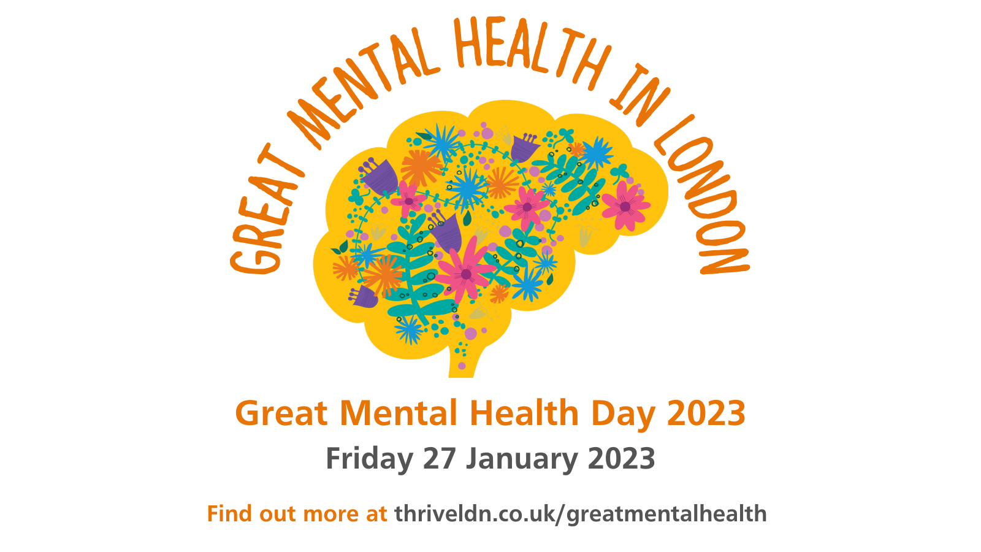  Alt text: A graphic of a floral brain with the words Great Mental Health in London written across the top. Below is Great Mental Health Day and the website address for more information.  Download image here.
(Pre-27 January 2023)  Twitter 2 | London's #GreatMentalHealth Day is back on Friday, 27 January.  🗺️ Learn more about the great local initiatives and support services that are available right across London.  📅 Take part in a local or virtual event with fellow Londoners to mark the day: www.thriveldn.co.uk/greatmentalhealth
(Pre-27 January 2023)  Twitter 3 | For Great Mental Health Day 2023 we're asking:  1️⃣ In three words, what does #GreatMentalHealth mean to you?  2️⃣ How have you been supporting others in your community?  3️⃣ What examples of community kindness have stayed with you?  To find out more: www.thriveldn.co.uk/greatmentalhealth
(Pre-27 January 2023)  Twitter 4 | 📢 The countdown to Great Mental Health Day 2023 has started!  This year we’re celebrating the power of community kindness and sharing stories of how Londoners have come together for each other.  In three words, what does #GreatMentalHealth mean to you?  www.thriveldn.co.uk/greatmentalhealth
(Pre-27 January 2023)  Twitter 5 | London’s Great Mental Health Day is back on Friday, 27 January 2023!  This year we want to tell the story of how we’ve come together for one another across London and celebrate those who have made a difference.  Who will you be celebrating in your community?  #GreatMentalHealth
(Pre-27 January 2023)  Instagram | We’re delighted to be supporting Great Mental Health Day when it returns on Friday, 27 January 2023.  In a year that’s remained challenging for many of us, it has been our communities, friends and families which have played the most important role in getting us through difficult times together. That’s why Great Mental Health Day 2023 will celebrate the power of community kindness and tell the story of how we’ve come together for one another across London.  With plans already taking shape for what promises to be an action-packed day, we’re asking you to think about how you’d like to get involved and celebrate Great Mental Health Day 2023.  Follow the link in @ThriveLDN’s bio to find out more about #GreatMentalHealth and how you can join in. | Download image here  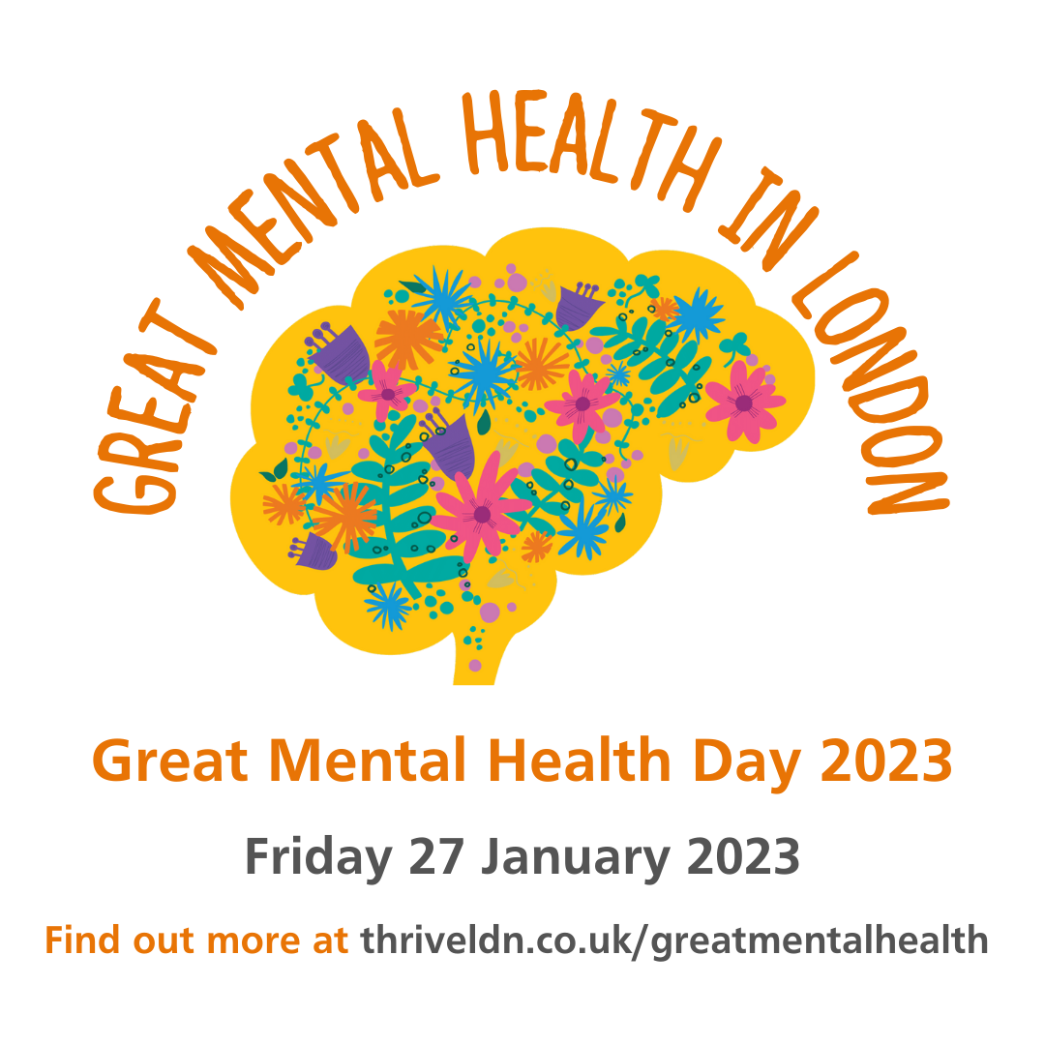  Alt text: A graphic of a floral brain with the words Great Mental Health in London written across the top. Below is Great Mental Health Day and the website address for more information.
(Pre-27 January 2023 or on 27 January 2023)  Instagram story | Add the following link to the suggest graphic:  https://thriveldn.co.uk/communications/campaign/great-mental-health-day-2023/ | 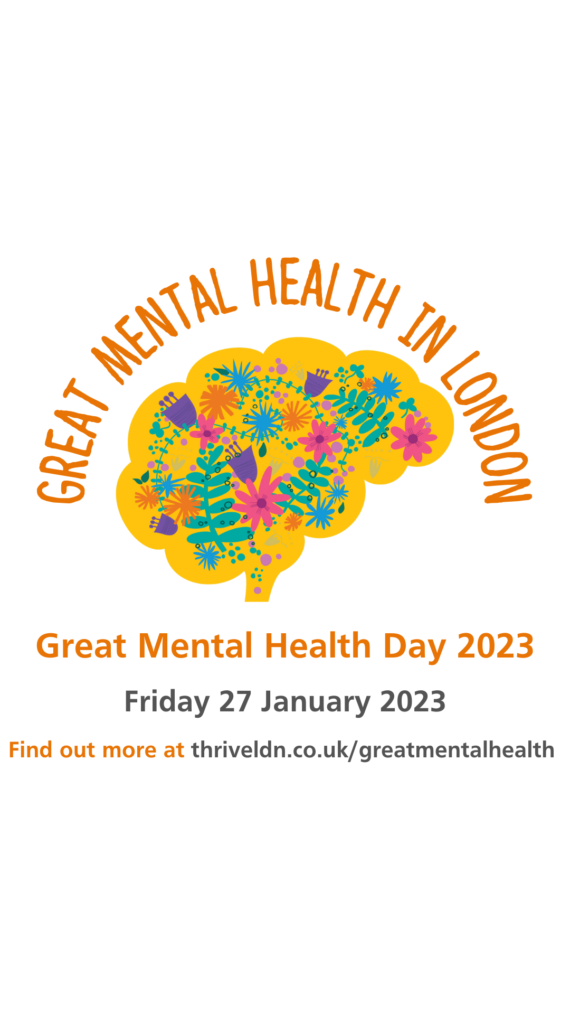  Download image here.
(Pre-27 January 2023)  Facebook and LinkedIn | We’re delighted to be supporting Great Mental Health Day when it returns on Friday, 27 January 2023.  In a year that’s remained challenging for many of us, it has been our communities, friends and families which have played the most important role in in getting us through difficult times together.  That’s why Great Mental Health Day 2023 will celebrate the power of community kindness and tell the story of how we’ve come together for one another across London.  With plans already taking shape for what promises to be an action-packed day, we’re asking you to think about how you’d like to get involved and celebrate Great Mental Health Day 2023.  Visit www.thriveldn.co.uk/greatmentalhealth to find out more about #GreatMentalHealth and how you can join in. | Download image here  Alt text: A graphic of a floral brain with the words Great Mental Health in London written across the top. Below is Great Mental Health Day and the website address for more information.

Social media content for Great Mental Health Day. To post on 27 January 2023
Channel | Suggested copy | Suggested digital asset (right click to ‘open link’ and download high resolution version)
(On 27 January 2023)  Twitter 1 | Today is London's Great Mental Health Day.  It's a chance to talk about mental health by sharing positive stories about how we can support others in our community and celebrate the kindness shown by others towards you.  In three words, what does #GreatMentalHealth mean to you? | Alt text: A graphic of a floral brain with the words Great Mental Health in London written across the top. Below is Great Mental Health Day and the website address for more information.  Download image here.
(On 27 January 2023)  Twitter 2 | Today is London's Great Mental Health Day 2023!  🗣️ Today, find time to talk to someone you trust about your mental health and wellbeing.  🗺️ And learn more about the great local initiatives and support services that are available right across London.  www.thriveldn.co.uk/greatmentalhealth
(Pre-27 January 2023)  Twitter 2 | Today is Great Mental Health Day 2023. To mark the day, we would love to know the following:  1️⃣ In three words, what does #GreatMentalHealth mean to you?  2️⃣ How have you been supporting others in your community?  To find out more and take part: www.thriveldn.co.uk/greatmentalhealth
(Pre-27 January 2023)  Twitter 4 | Happy Great Mental Health Day, London!  This year we want to tell the story of how we’ve come together for one another across London and celebrate those who have made a difference.  Who will you be celebrating in your community?  #GreatMentalHealth  www.thriveldn.co.uk/greatmentalhealth
(On 27 January 2023)  Instagram | Today is Great Mental Health Day 2023!  All over London, we’re celebrating the power of community kindness and telling the story of how we’ve come together for one another across London.  There’s an action-packed line-up of events planned for today, but we want to ask you to sum up in just three words…  What does #GreatMentalHealth mean to you?  Let us know in the comments!  Follow the link in @ThriveLDN’s bio to find out more about #GreatMentalHealth and how you can access today’s events. | Download image here  Alt text: A graphic of a floral brain with the words Great Mental Health in London written across the top. Below is Great Mental Health Day and the website address for more information.
(On 27 January 2023)  Facebook and LinkedIn | Today is Great Mental Health Day 2023!  All over London, we’re celebrating the power of community kindness and telling the story of how we’ve come together for one another across London.  There’s an action-packed line-up of events planned for today, but we want to ask you to sum up in just three words…  What does #GreatMentalHealth mean to you?  Let us know in the comments!  To find out more about #GreatMentalHealth and how you can join in visit www.thriveldn.co.uk/greatmentalhealth | Download image here  Alt text: A graphic of a floral brain with the words Great Mental Health in London written across the top. Below is Great Mental Health Day and the website address for more information.

